Login into AWS console and navigate to Networking and Content Delivery and Select VPC

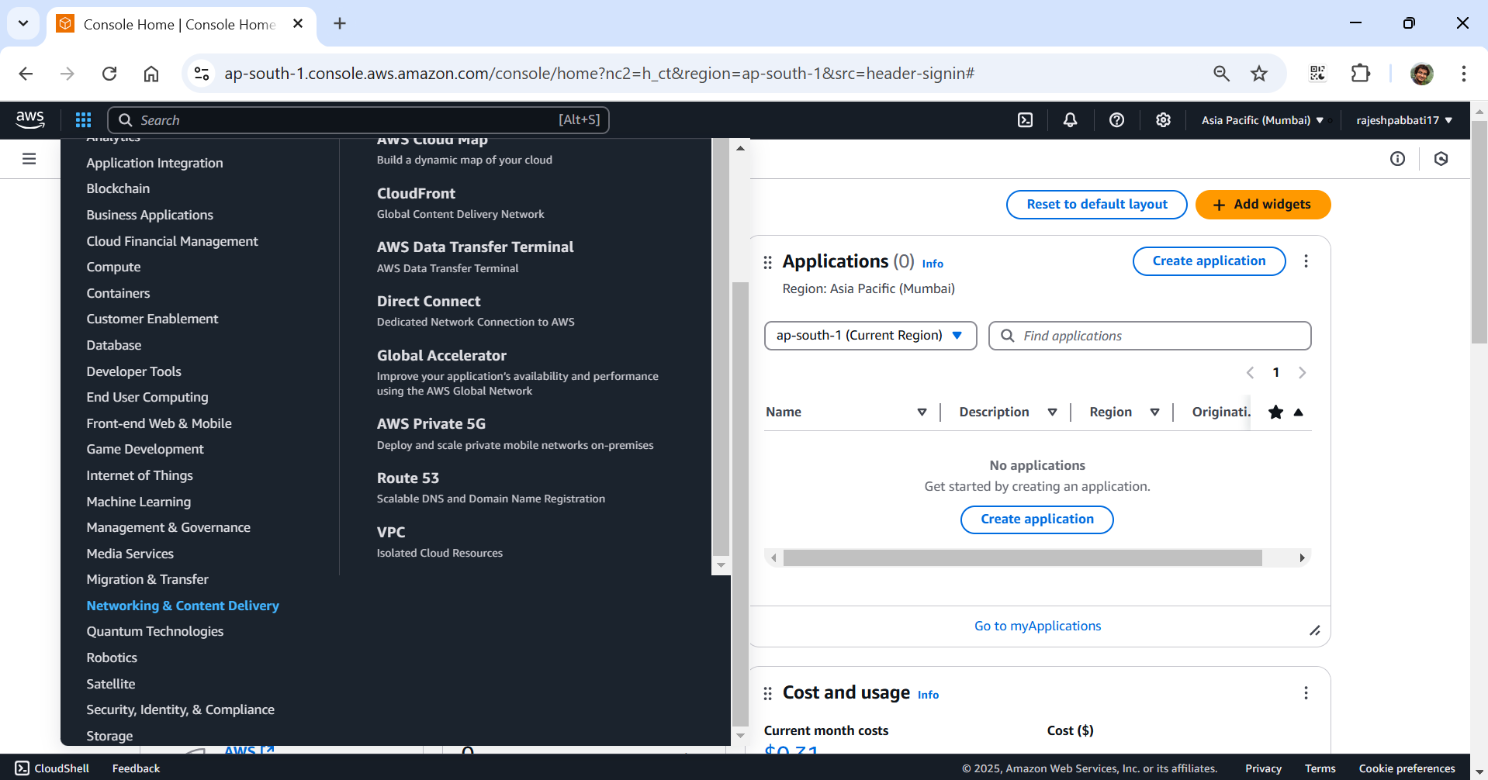

Click on Your VPCs

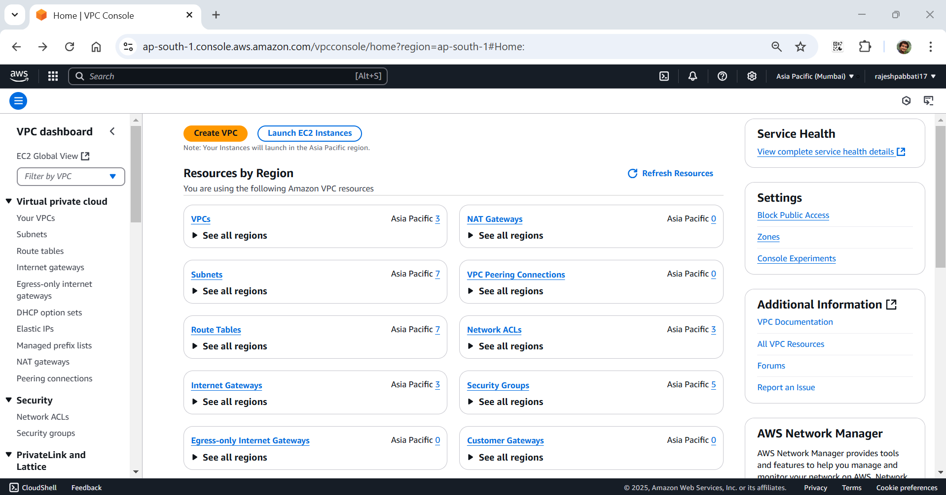

Click on Create VPC

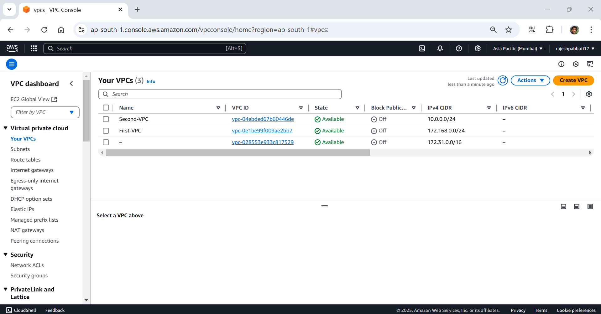

Select default settings and enter Name tag as my-vpc IPv4 CIDR value 10.0.0.0/16

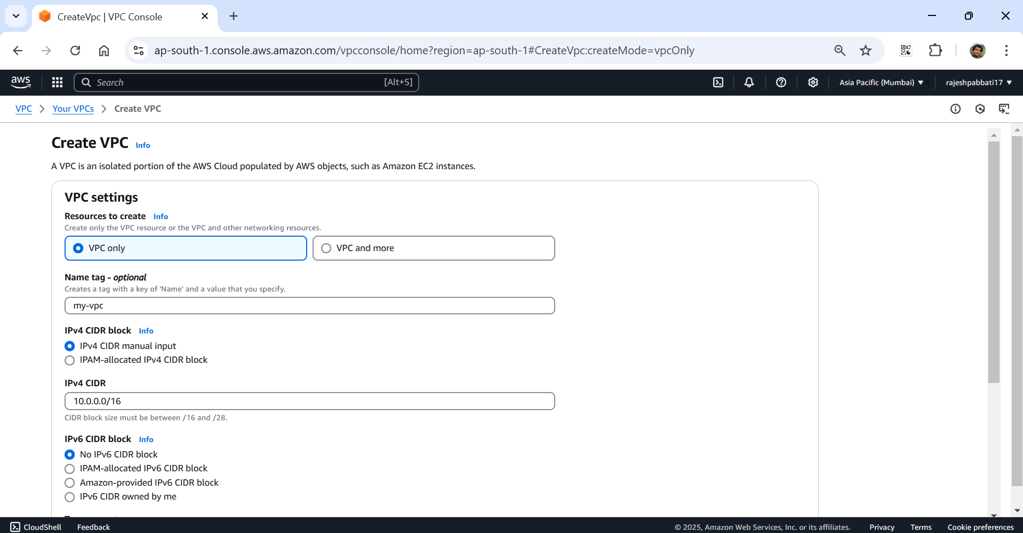

Click on Create VPC

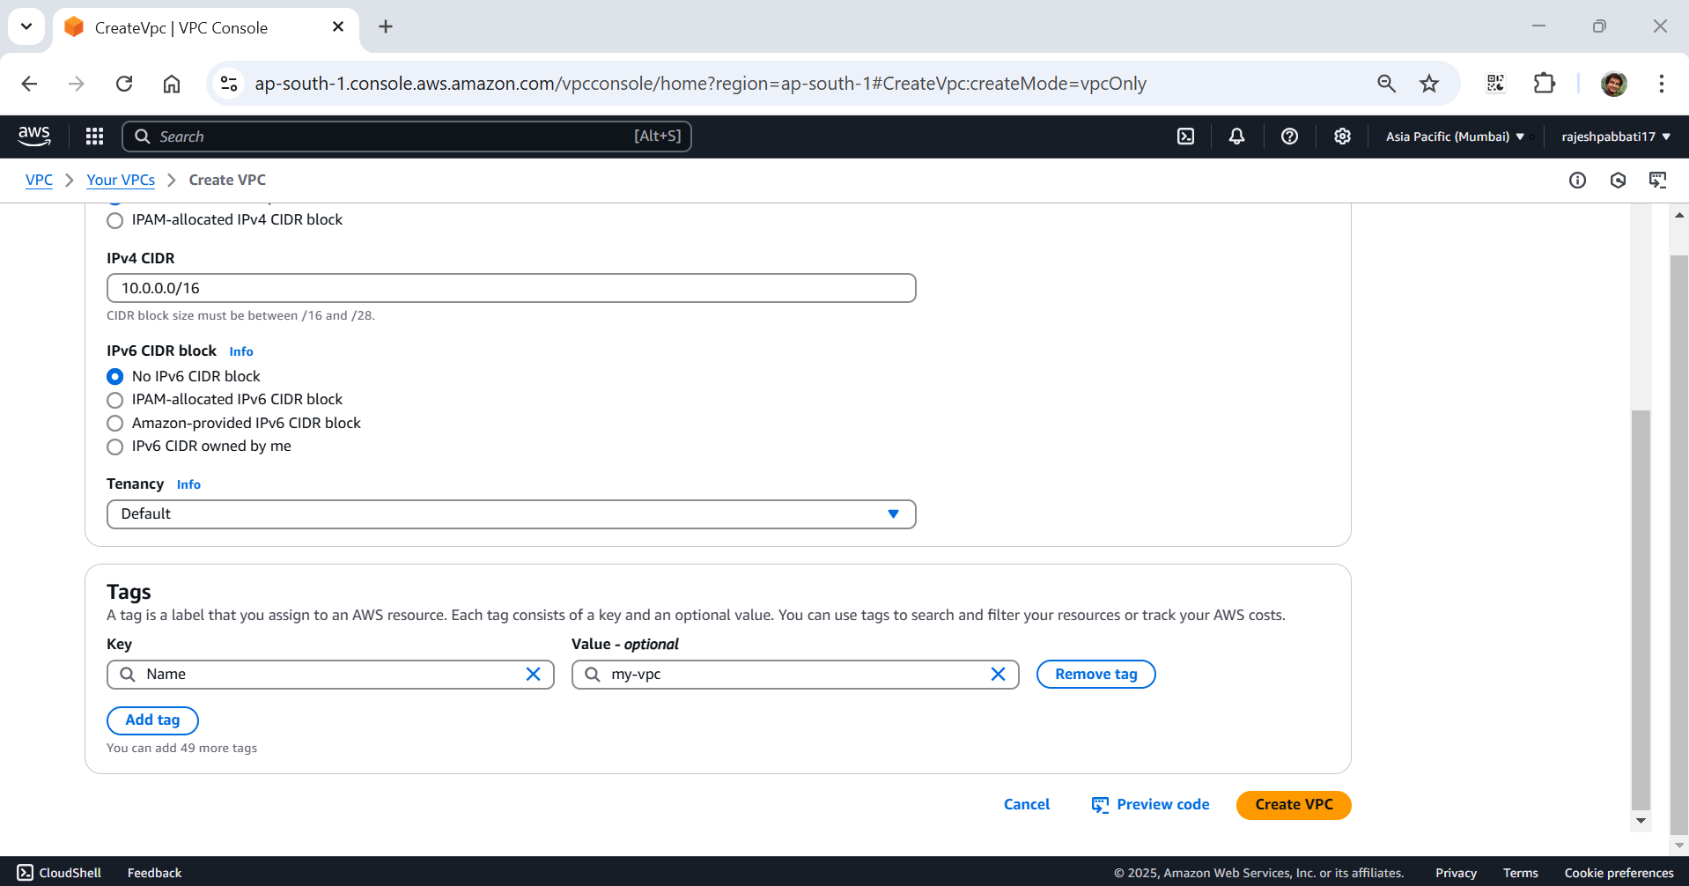

VPC created success message will be displayed

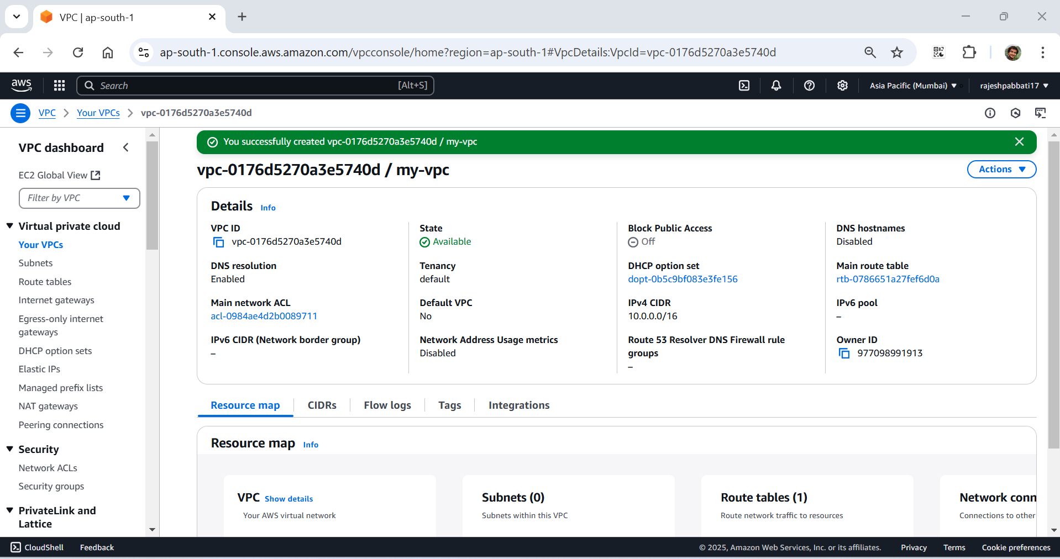

Select my-vpc and right click on Name of my-vpc and then click on Edit VPC settings

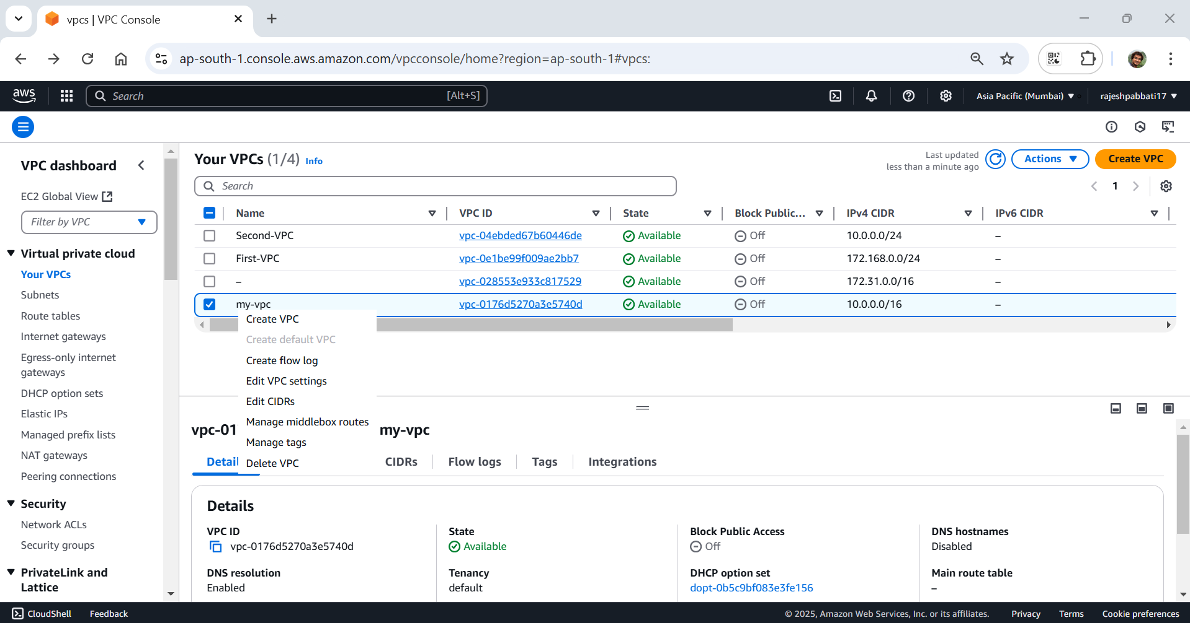

Tick the Enable DNS hostnames and click on save

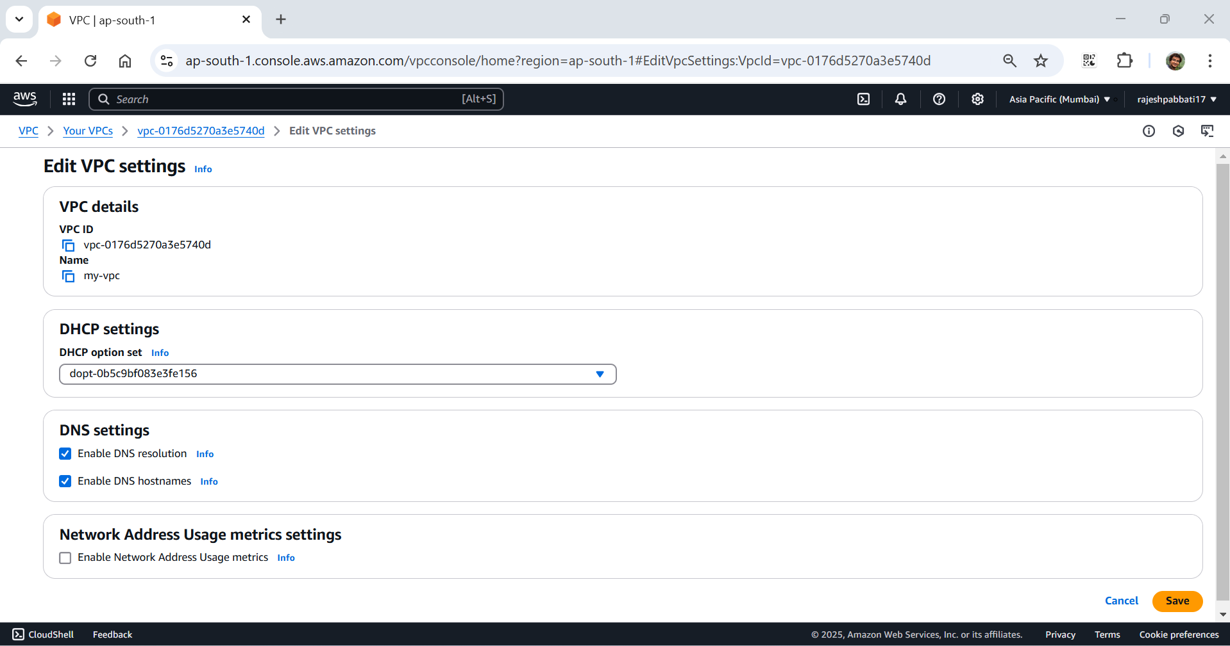

Click on subnets and then click on Create subnet

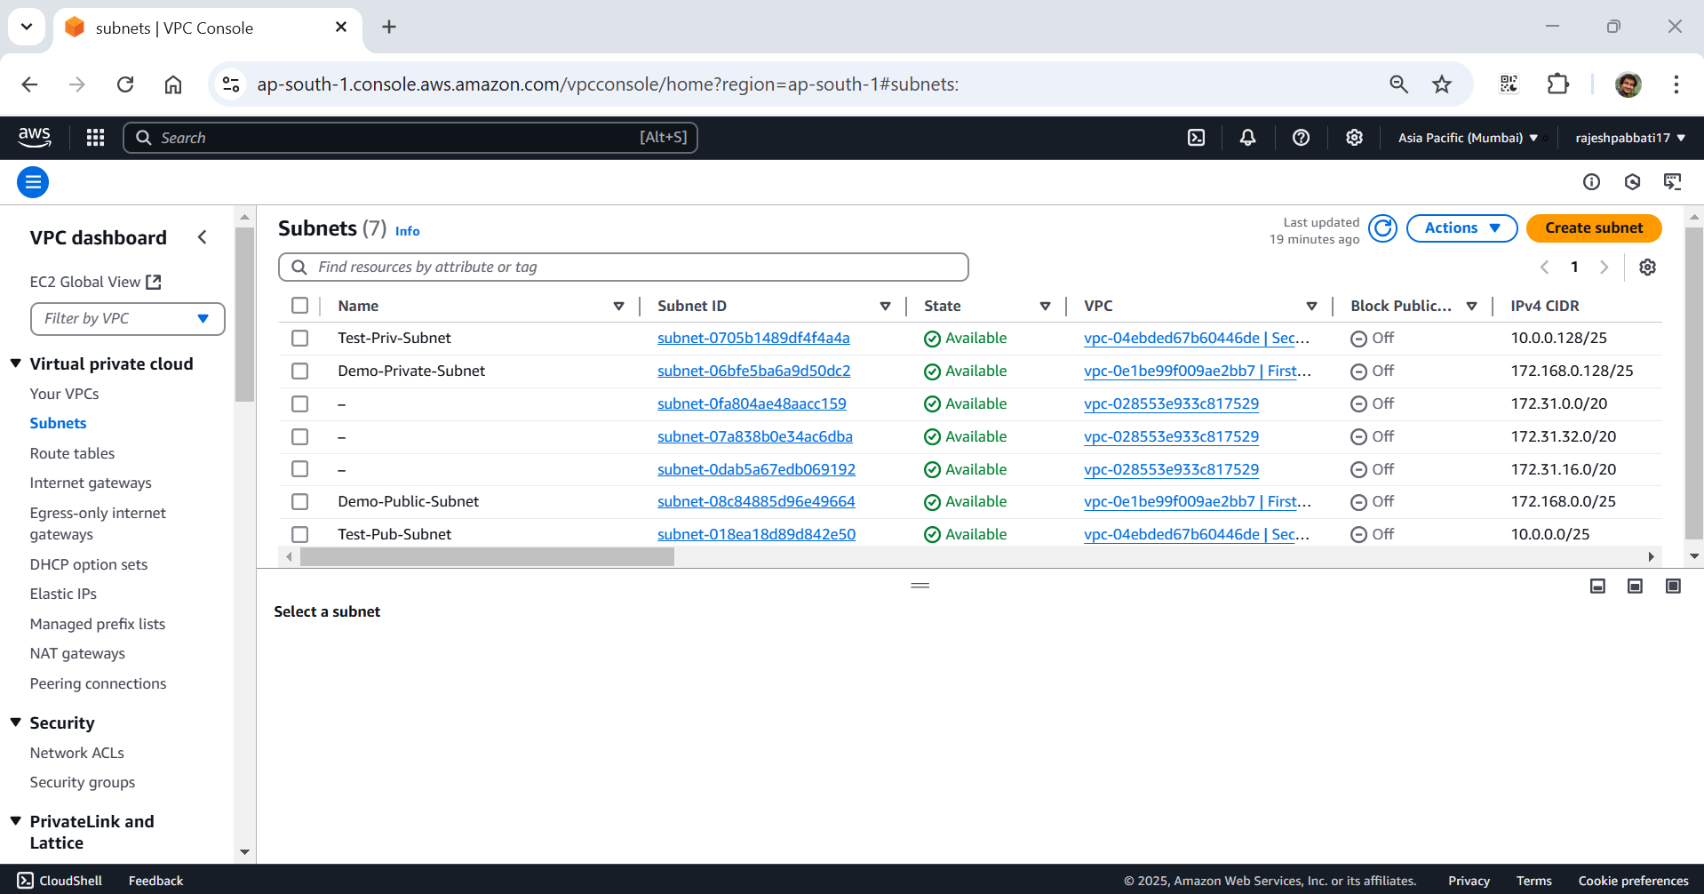

Select my-vpc and give subnet name as my-public-subnet

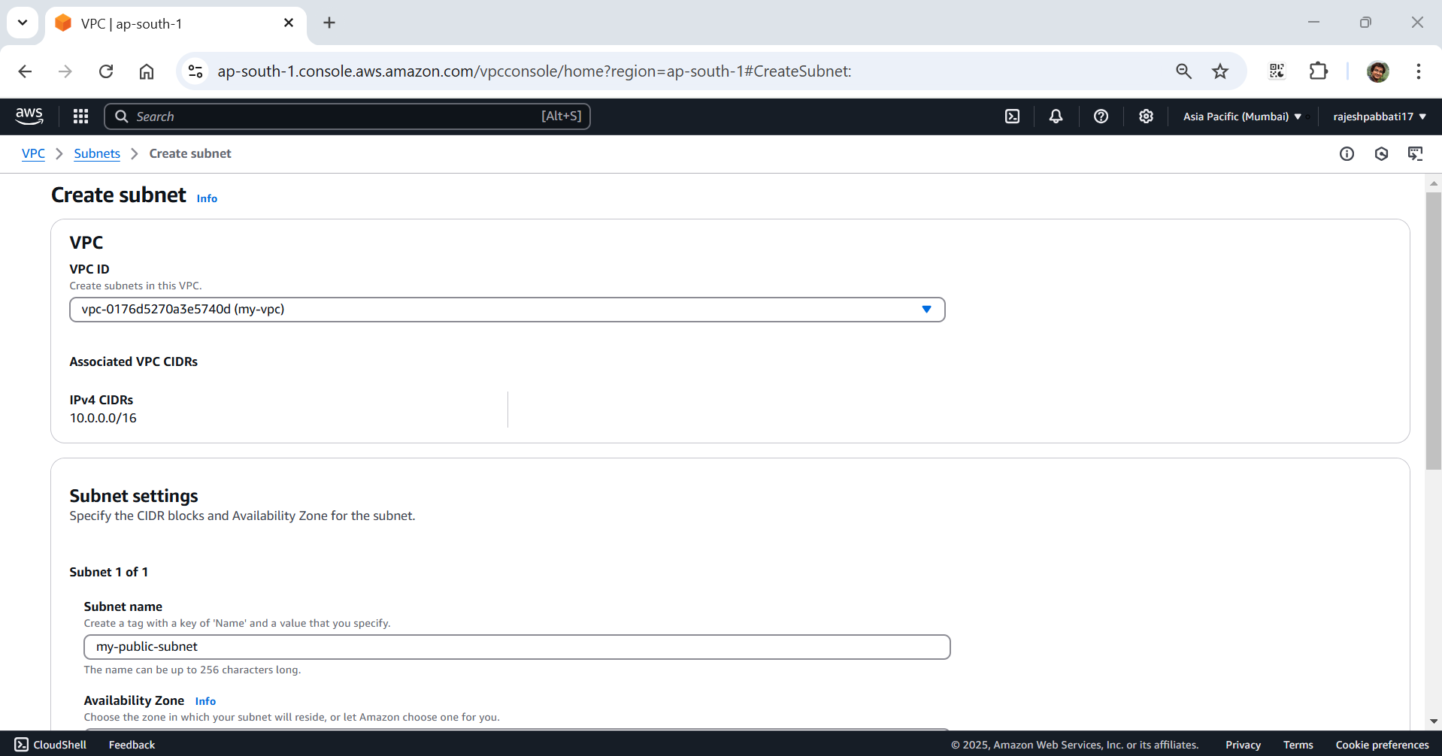

Select availability zone as ap-south-1a and give IPv4 subnet CIDR block as 10.0.0.0/25 and then click on create subnet

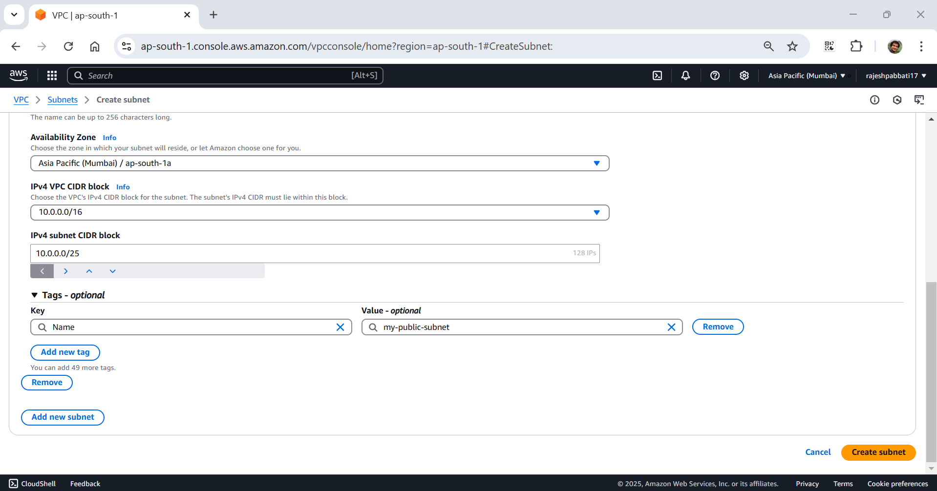

Subnet created message will be displayed and again click on Create subnet for another subnet which is private

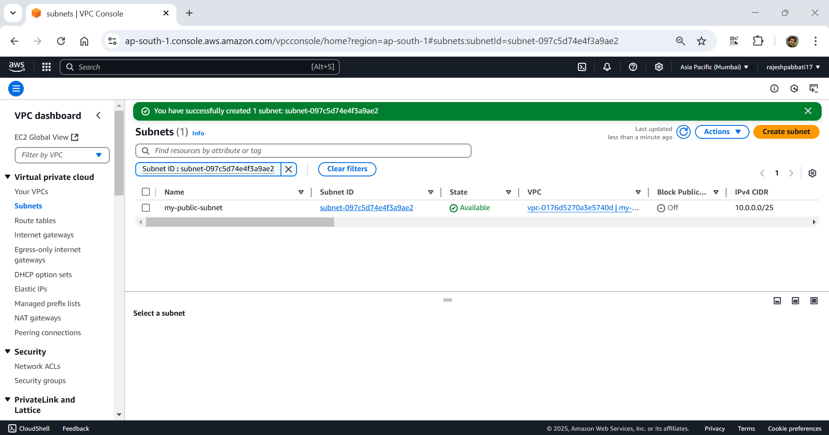

Select my-vpc and give subnet name as my-private-subnet

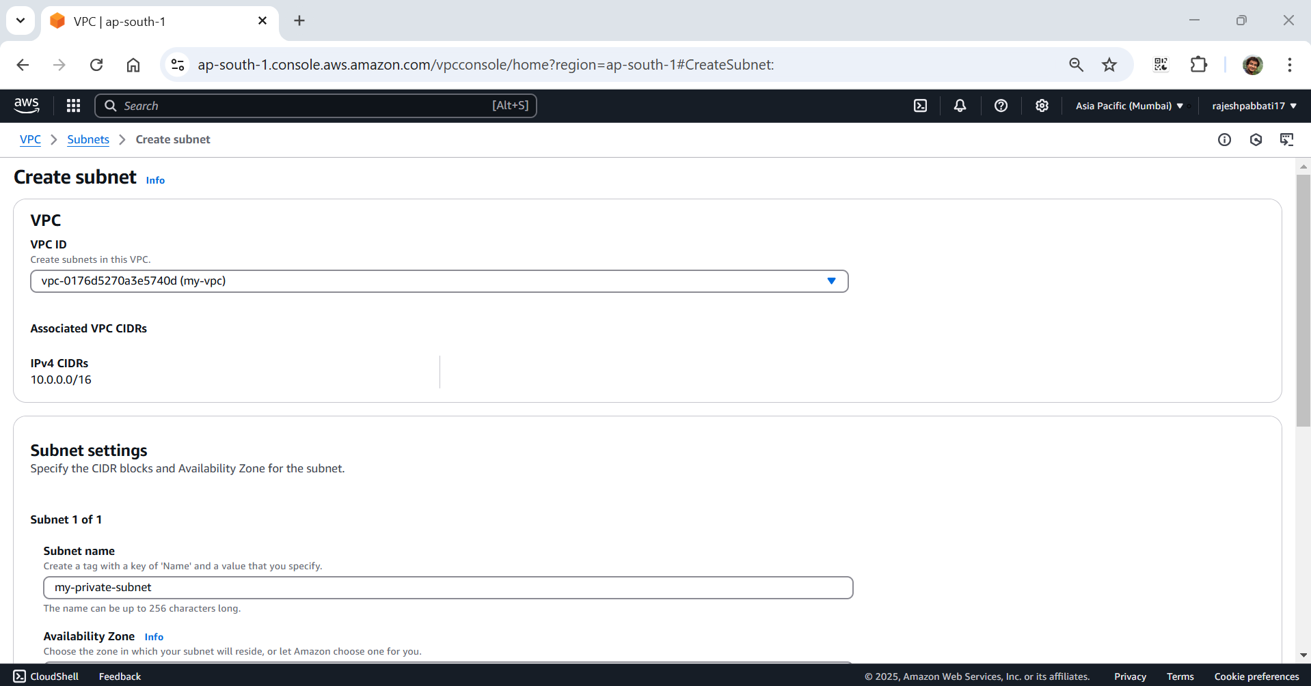

Select Availability zone as ap-south-1b and enter IPv4 VPC CIDR block as 10.0.0.128/25 and click on create subnet

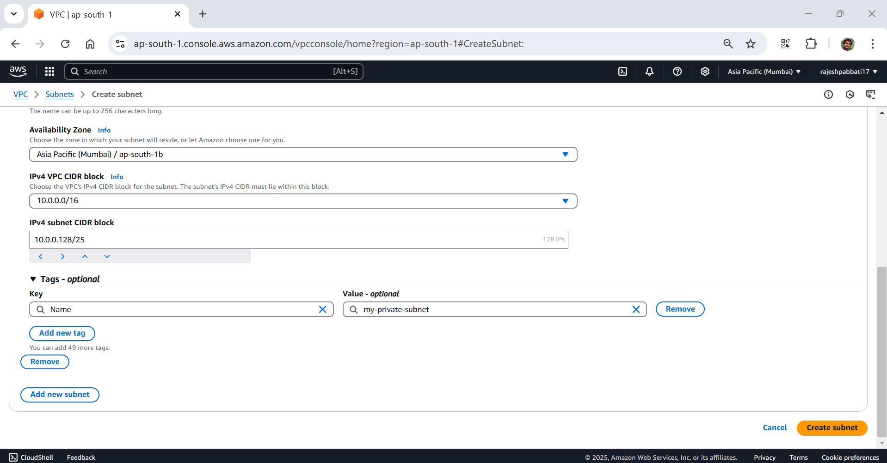

My-private-subnet successfully create message will be displayed

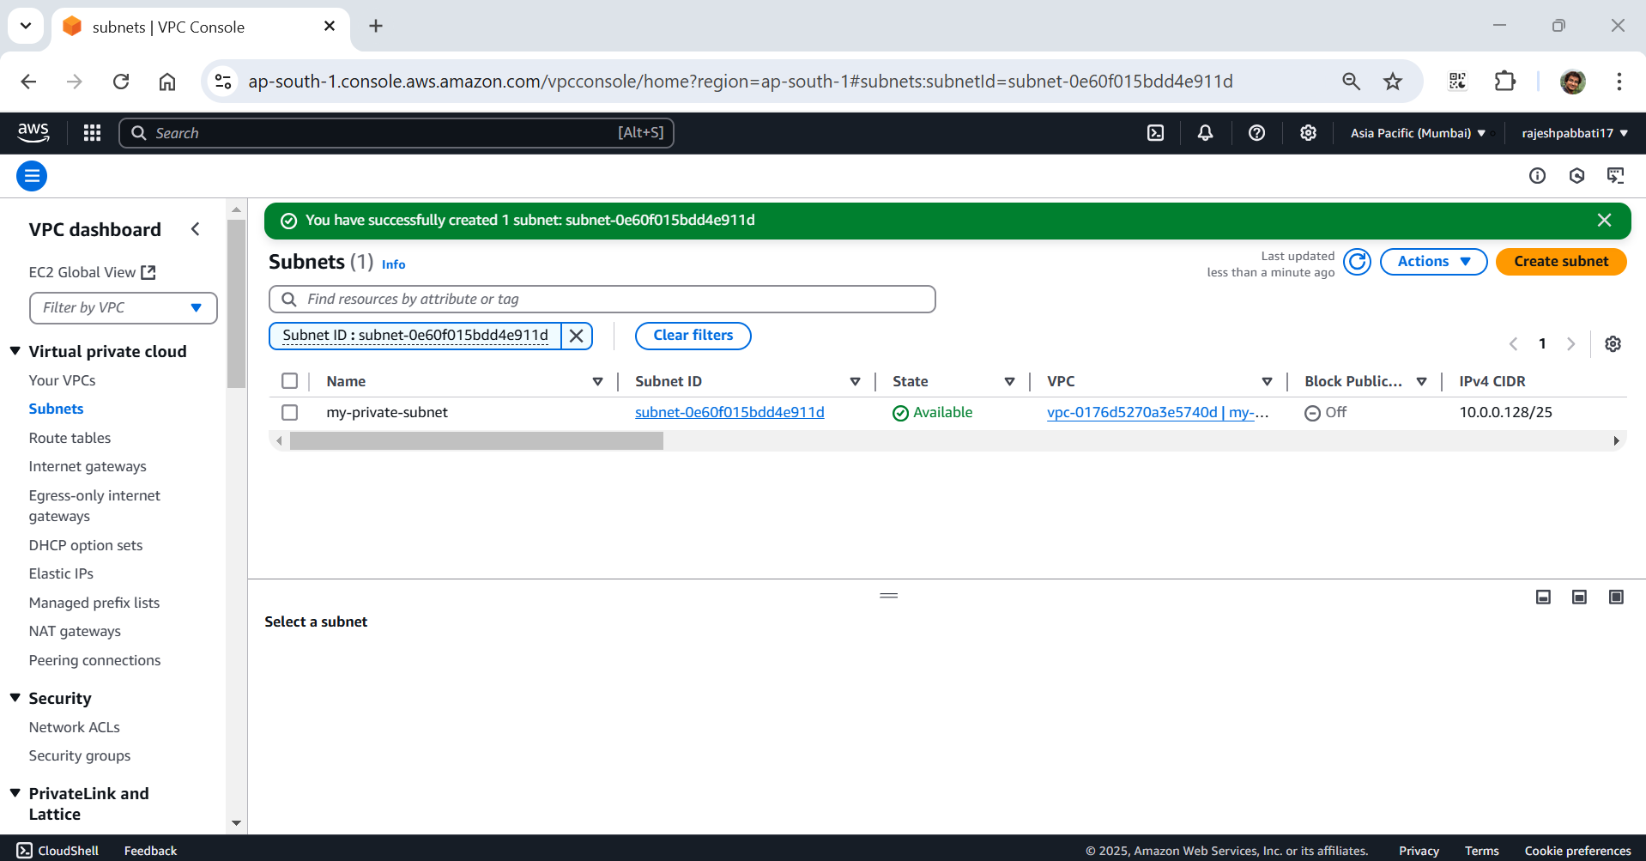

Tick the my-public subnet and right and click on edit subnet settings

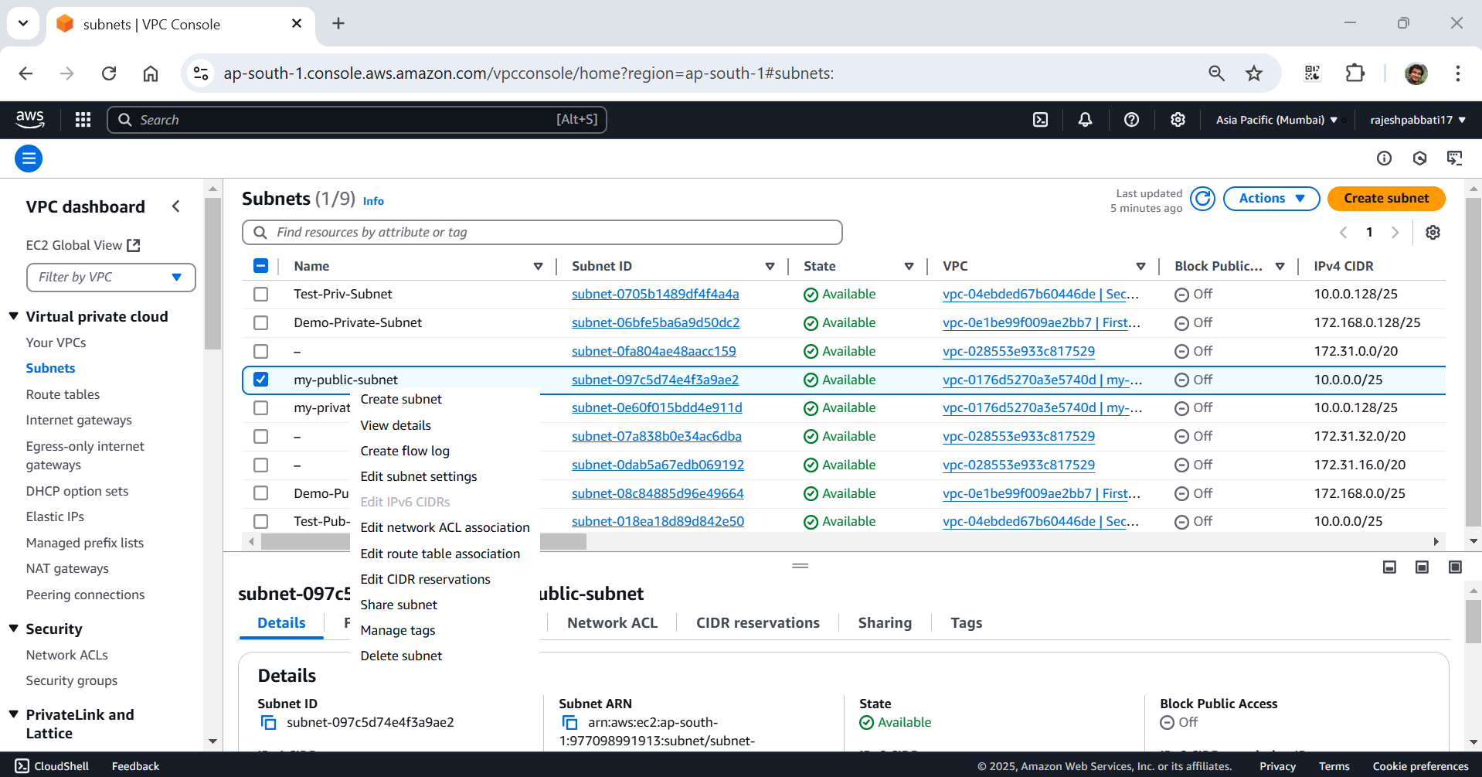

Tick the Enable auto-assign public IPv4 address

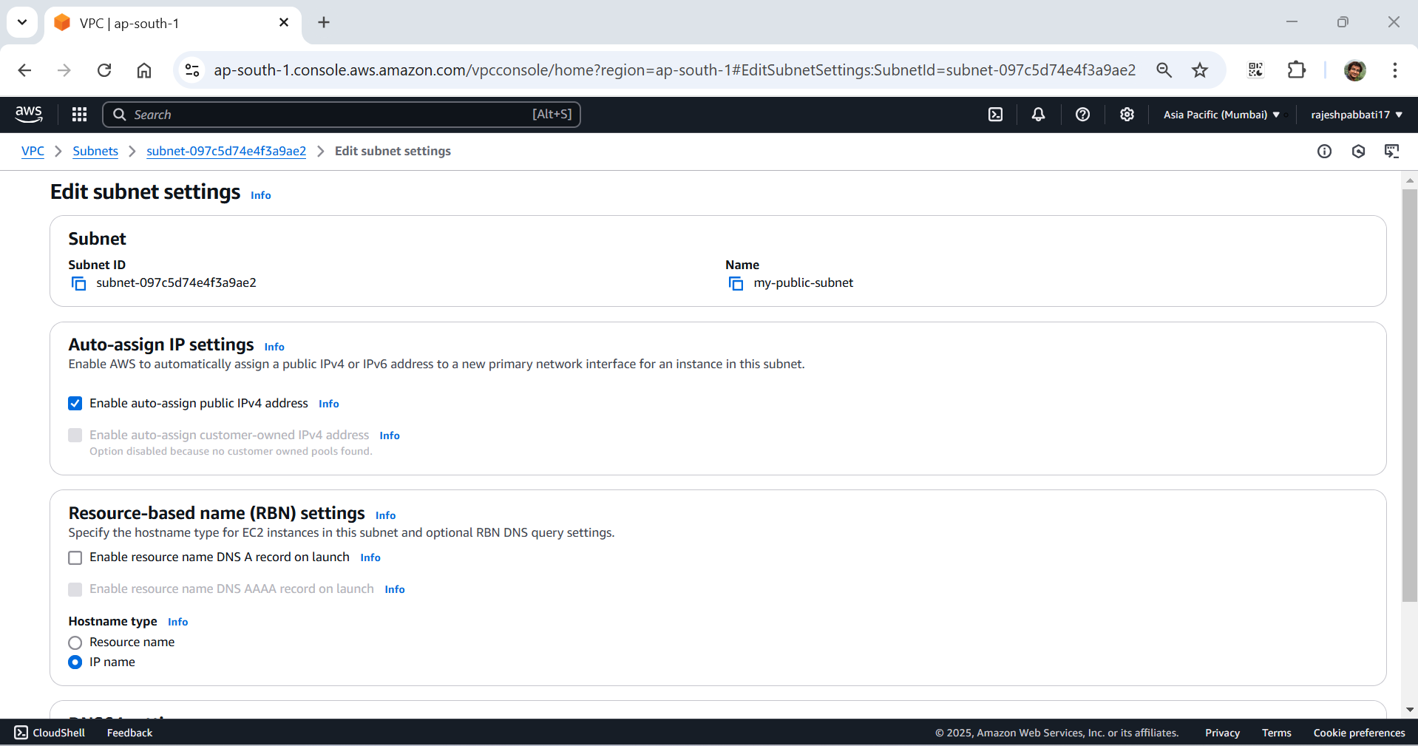

Click on Internet gateways

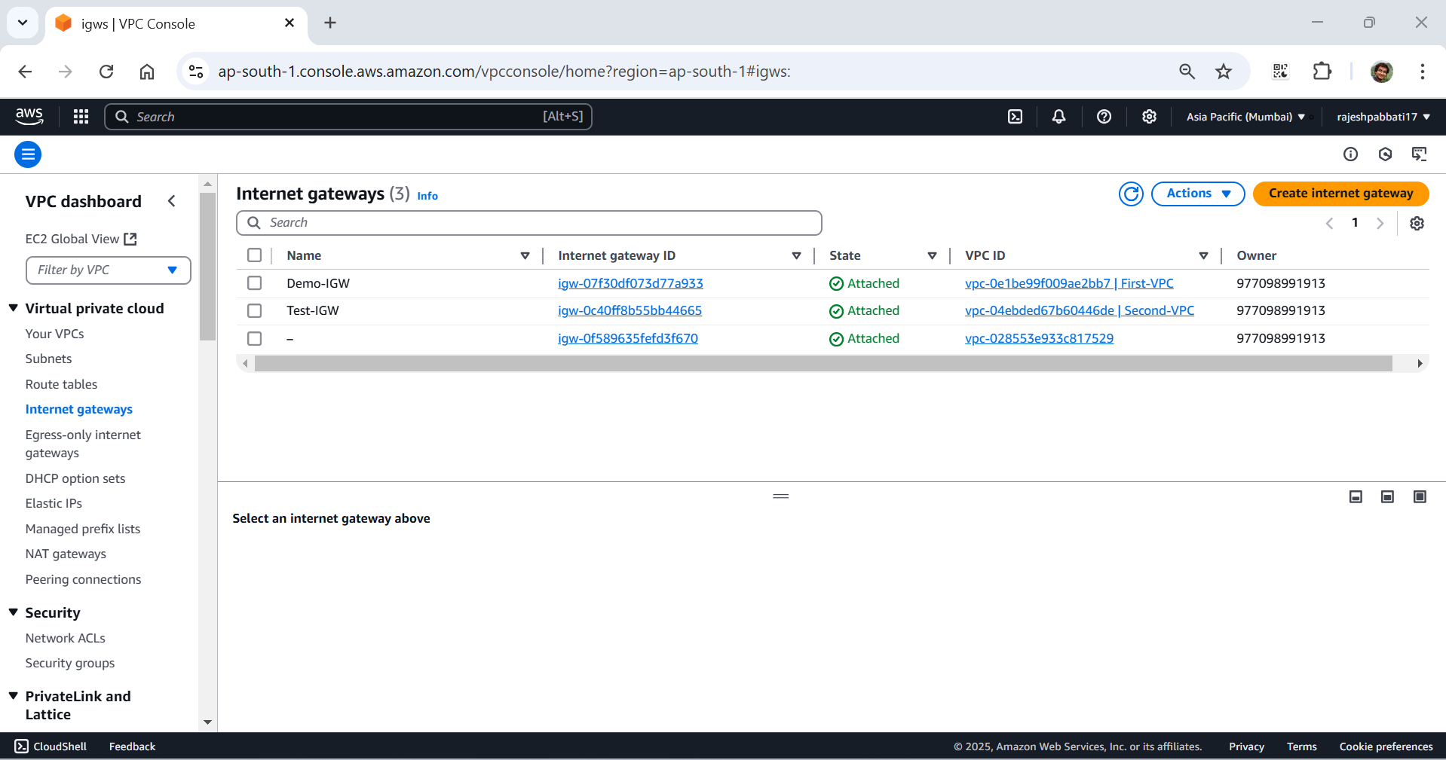

Ente Name as my-IGW and click on create internet gateway

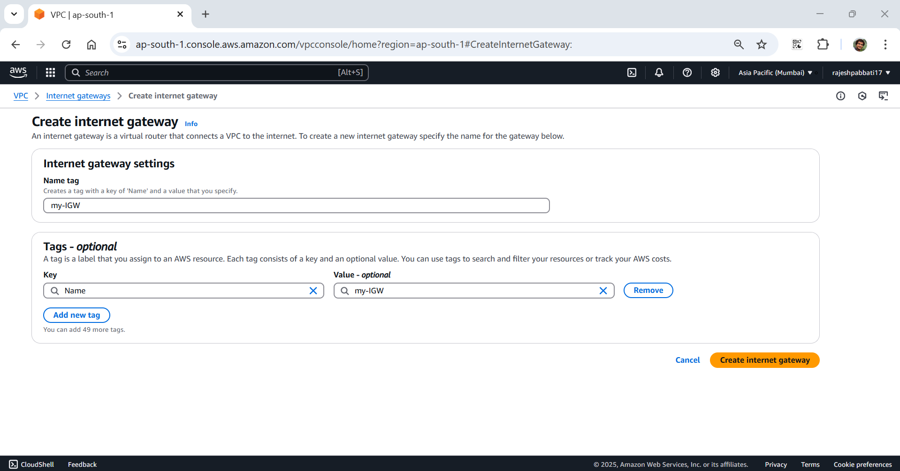

IGW created successfully message will be displayed and click on Attach to a VPC

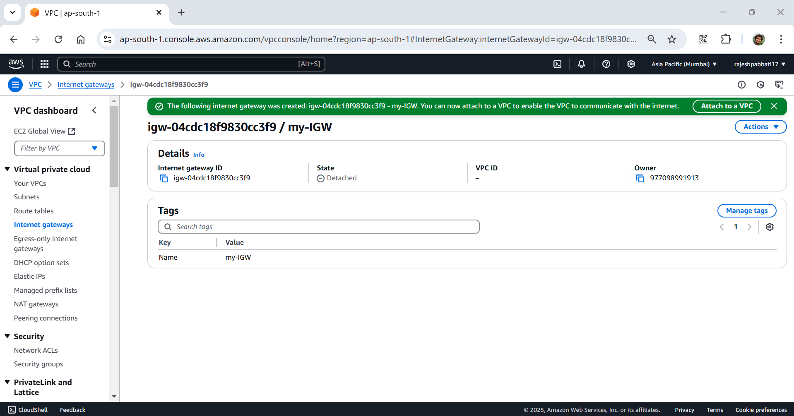

select my-vpc and click on Attach internet gateway

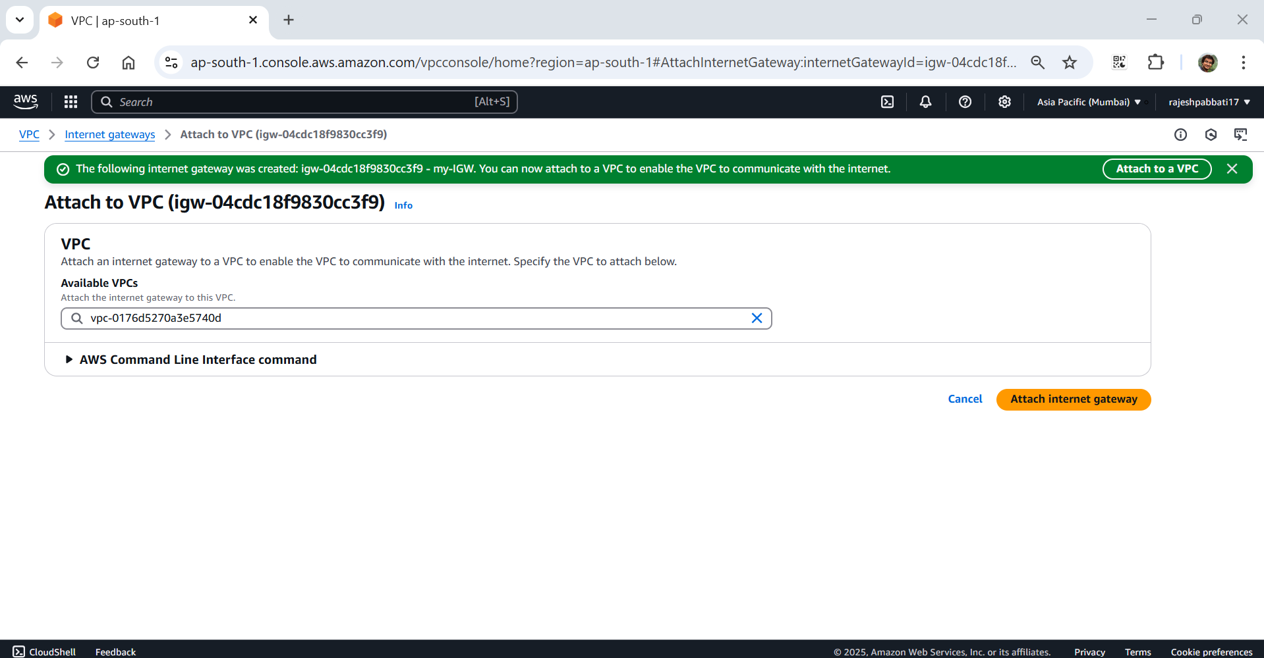

IGW attached to VPC message will be displayed

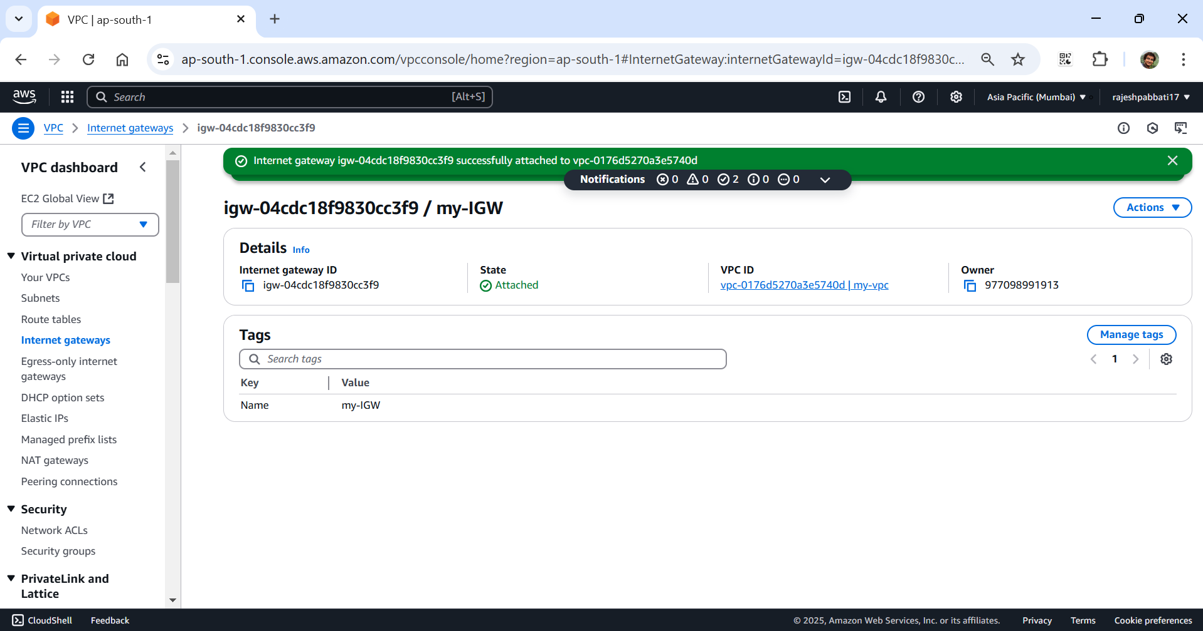

Click on Route tables and then click on Create route table

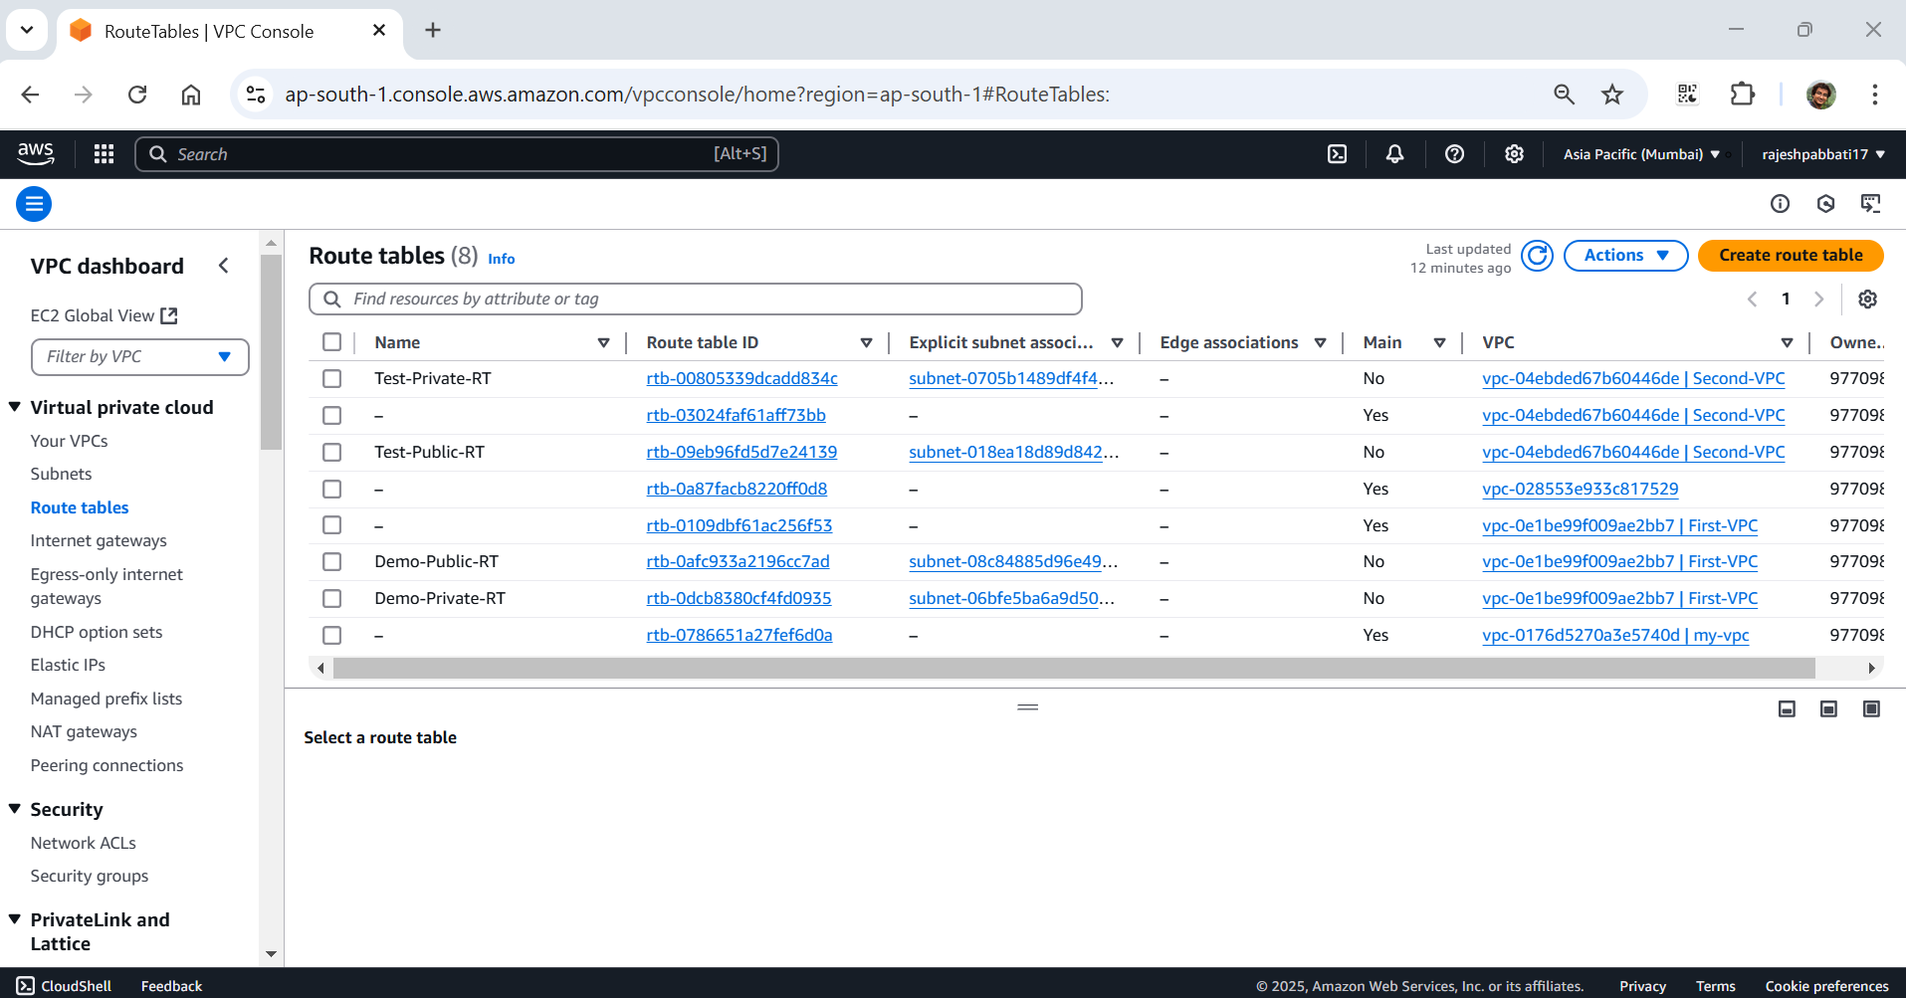

Enter my-public-RT and select my-vpc and then click on Create route table

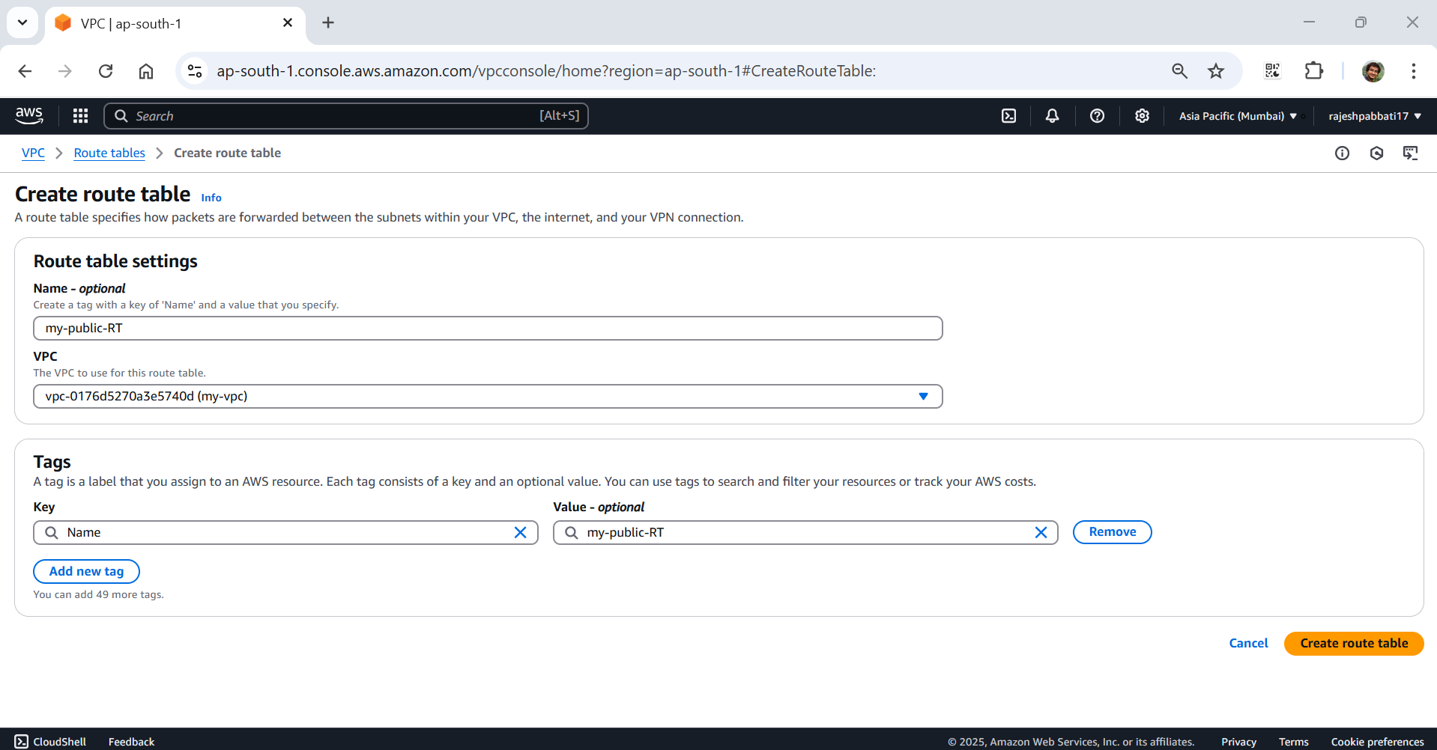

Route table created success message will be displayed then under Routes click on Edit routes

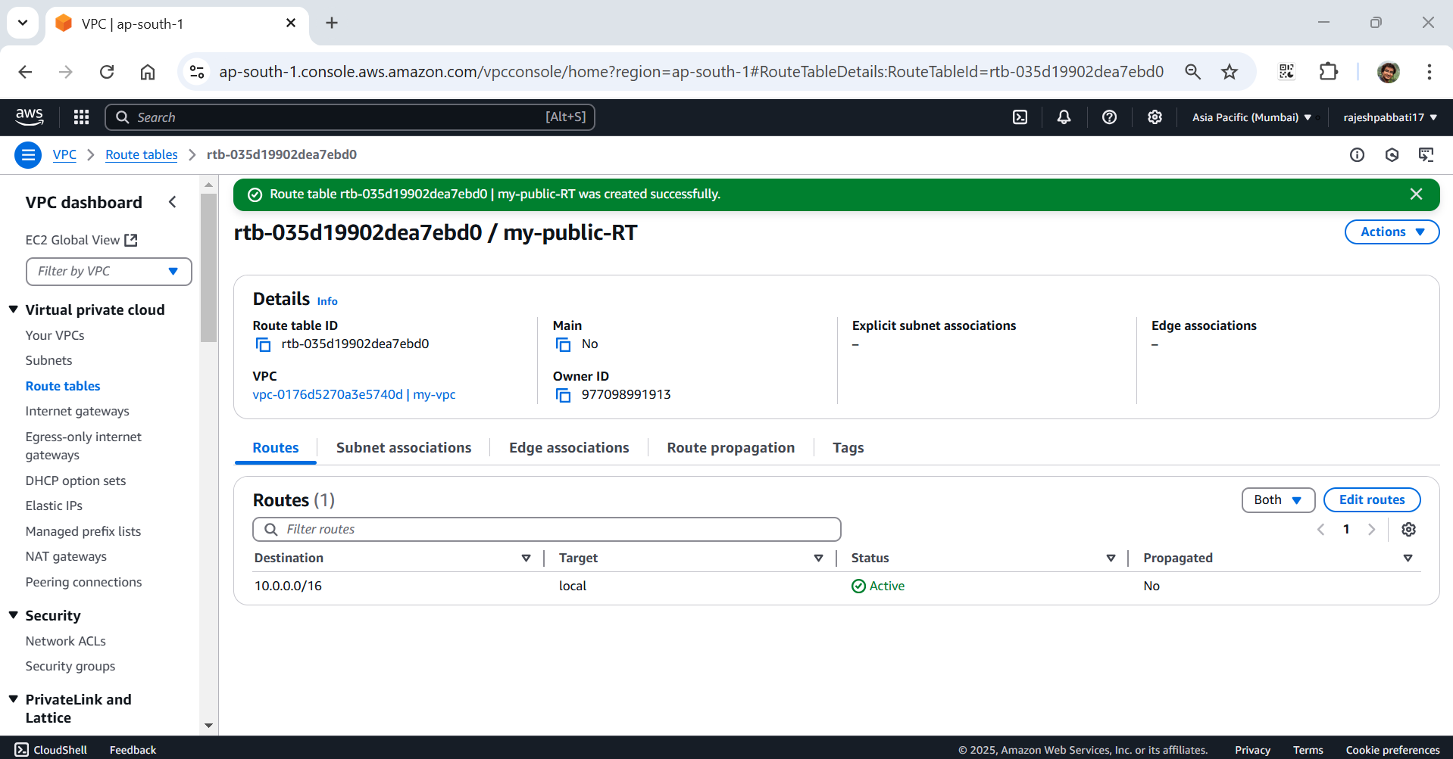

Click on Add rout and select Destination 0.0.0.0/0 and Target as Internet Gateway and below select igw and click on Save changes

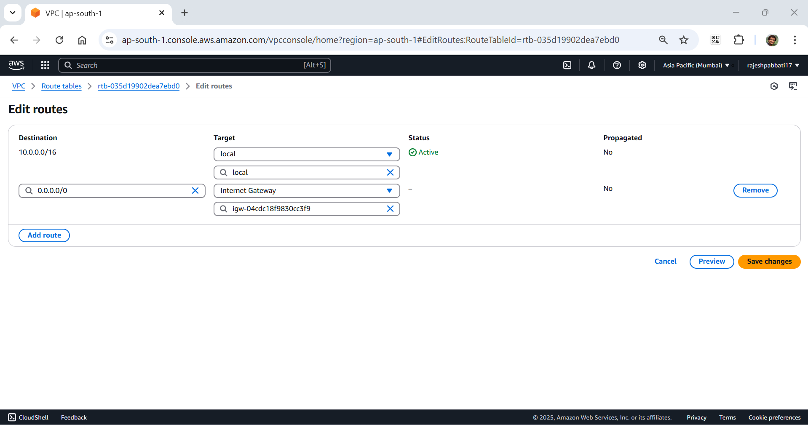

Success message will display under subnet associations click on Edit subnet associations

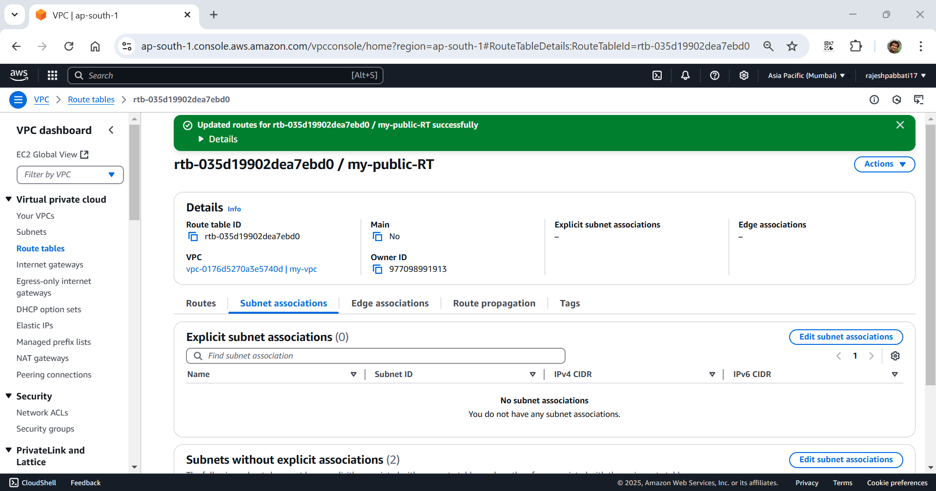

Select my-public-subnet and click on save associations

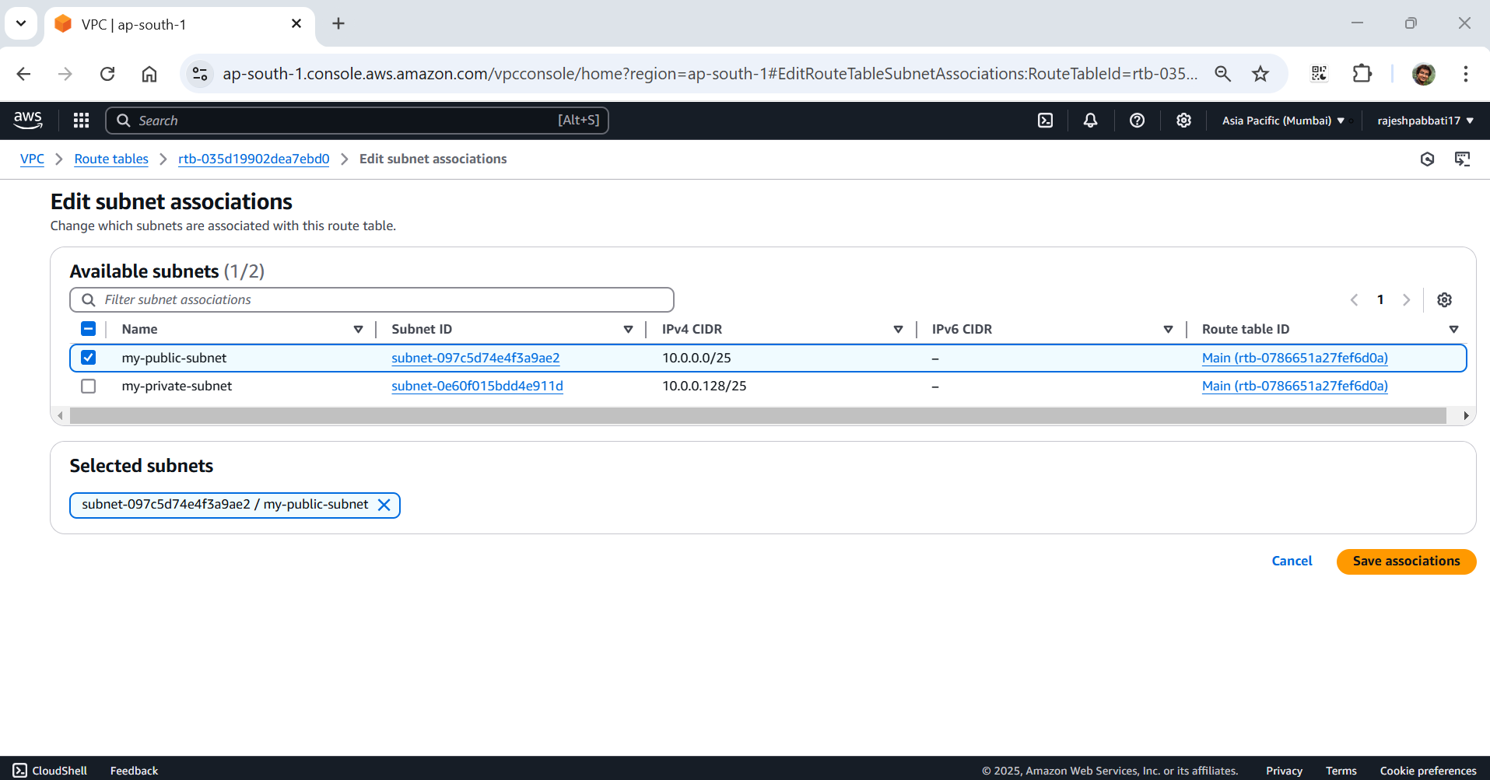

Click on create route tables

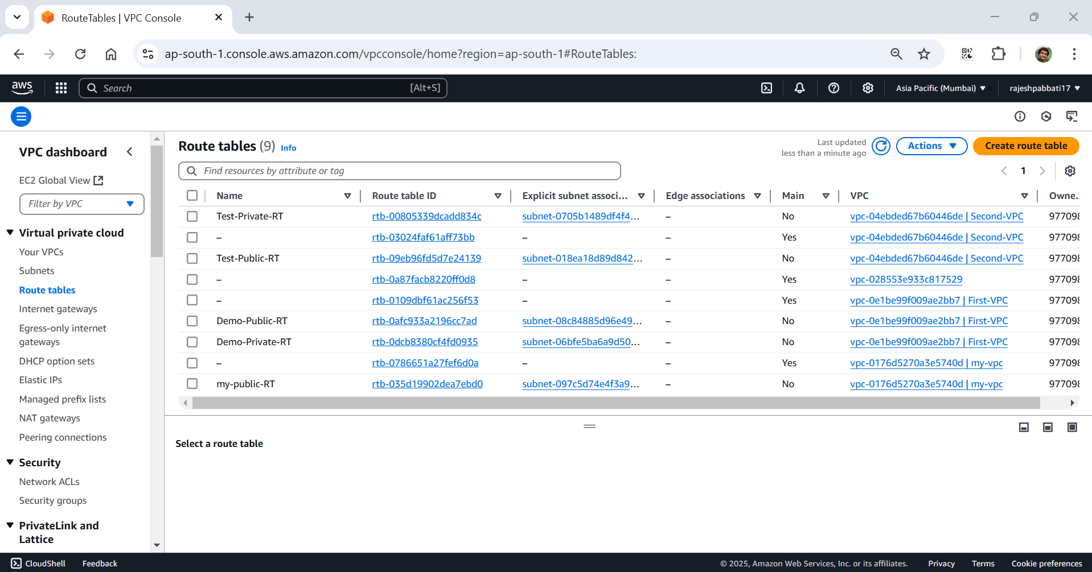

Enter name as my-private-RT and select my-vpc and click on Create route table

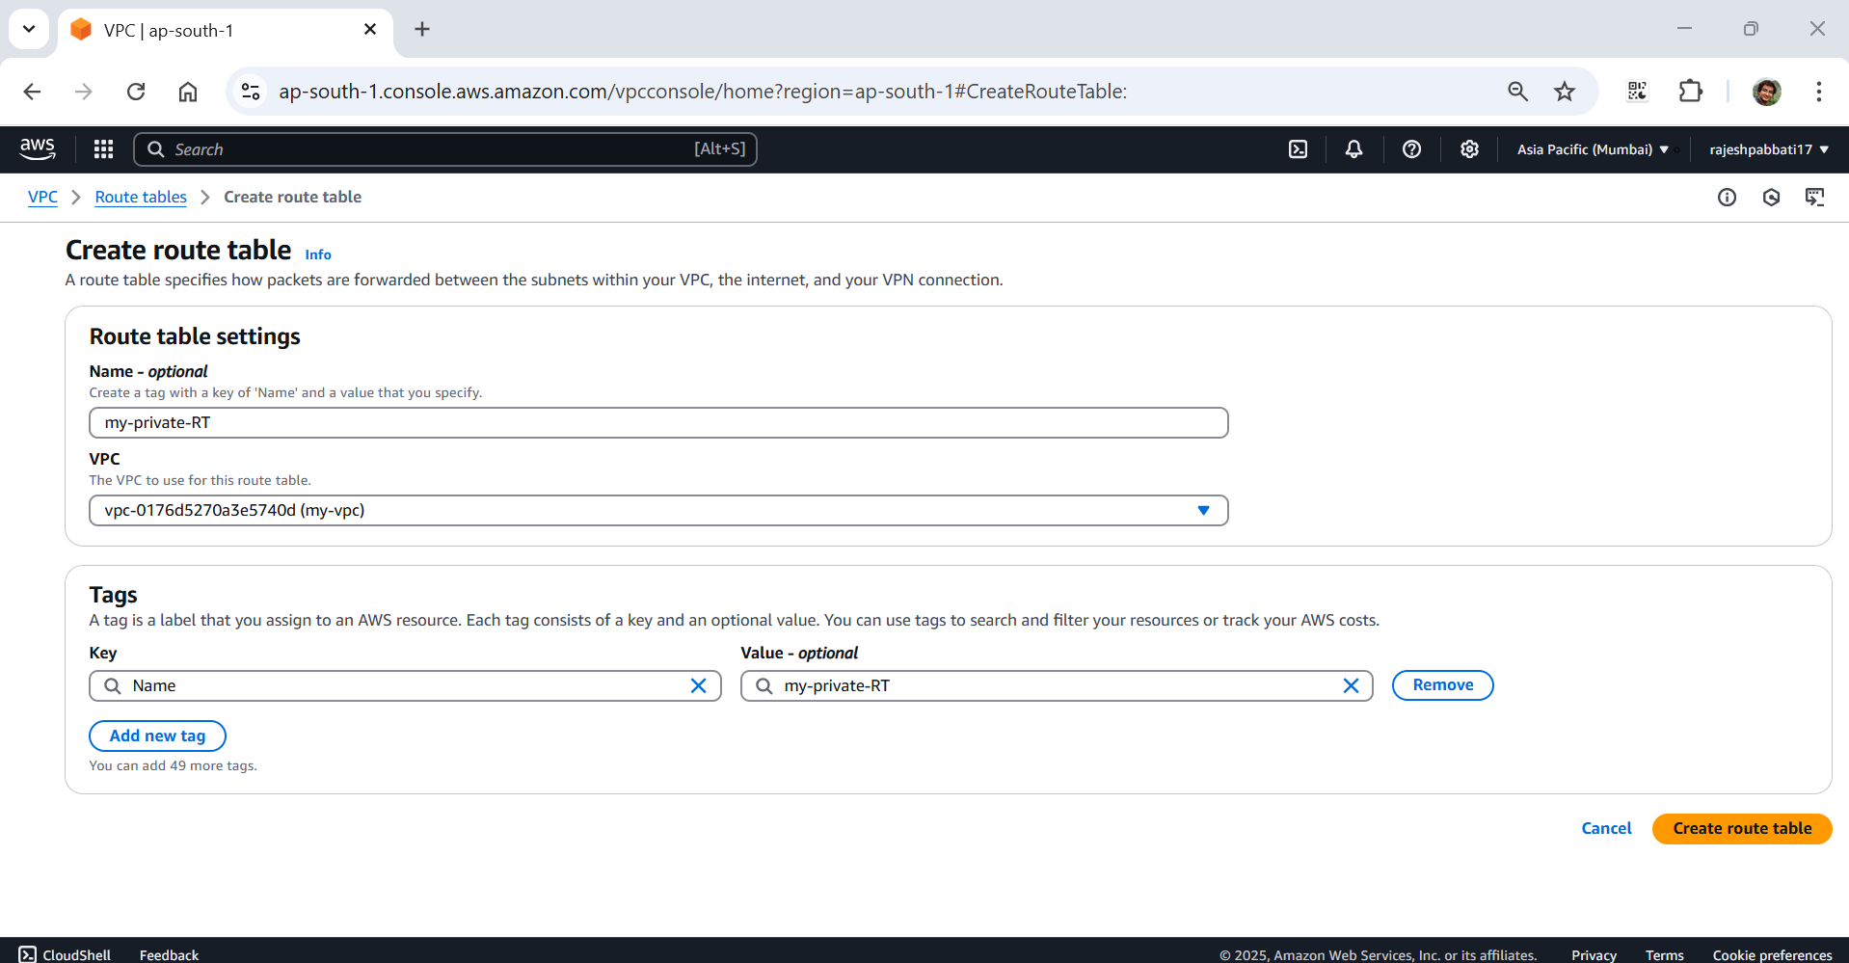

Success message will be display

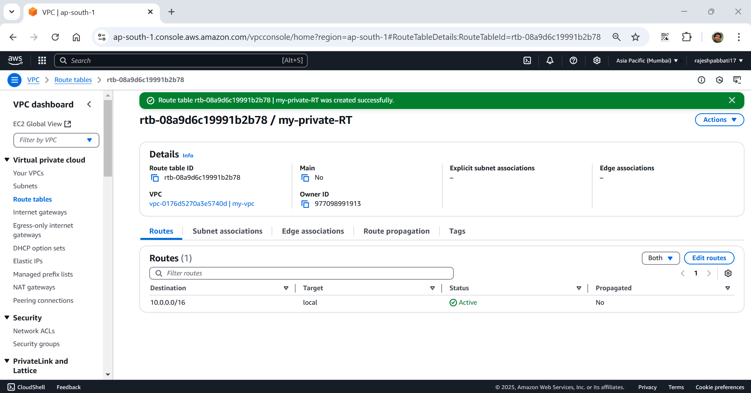

Click on Subnet associations and then click on Edit subnet associations

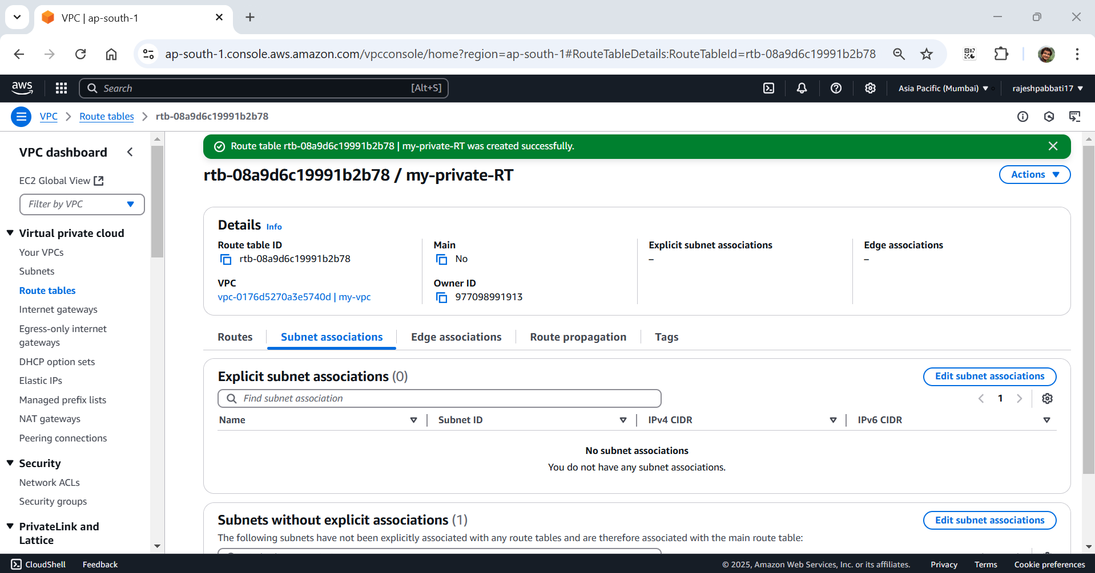

Select my-private-subnet and click on Save associations

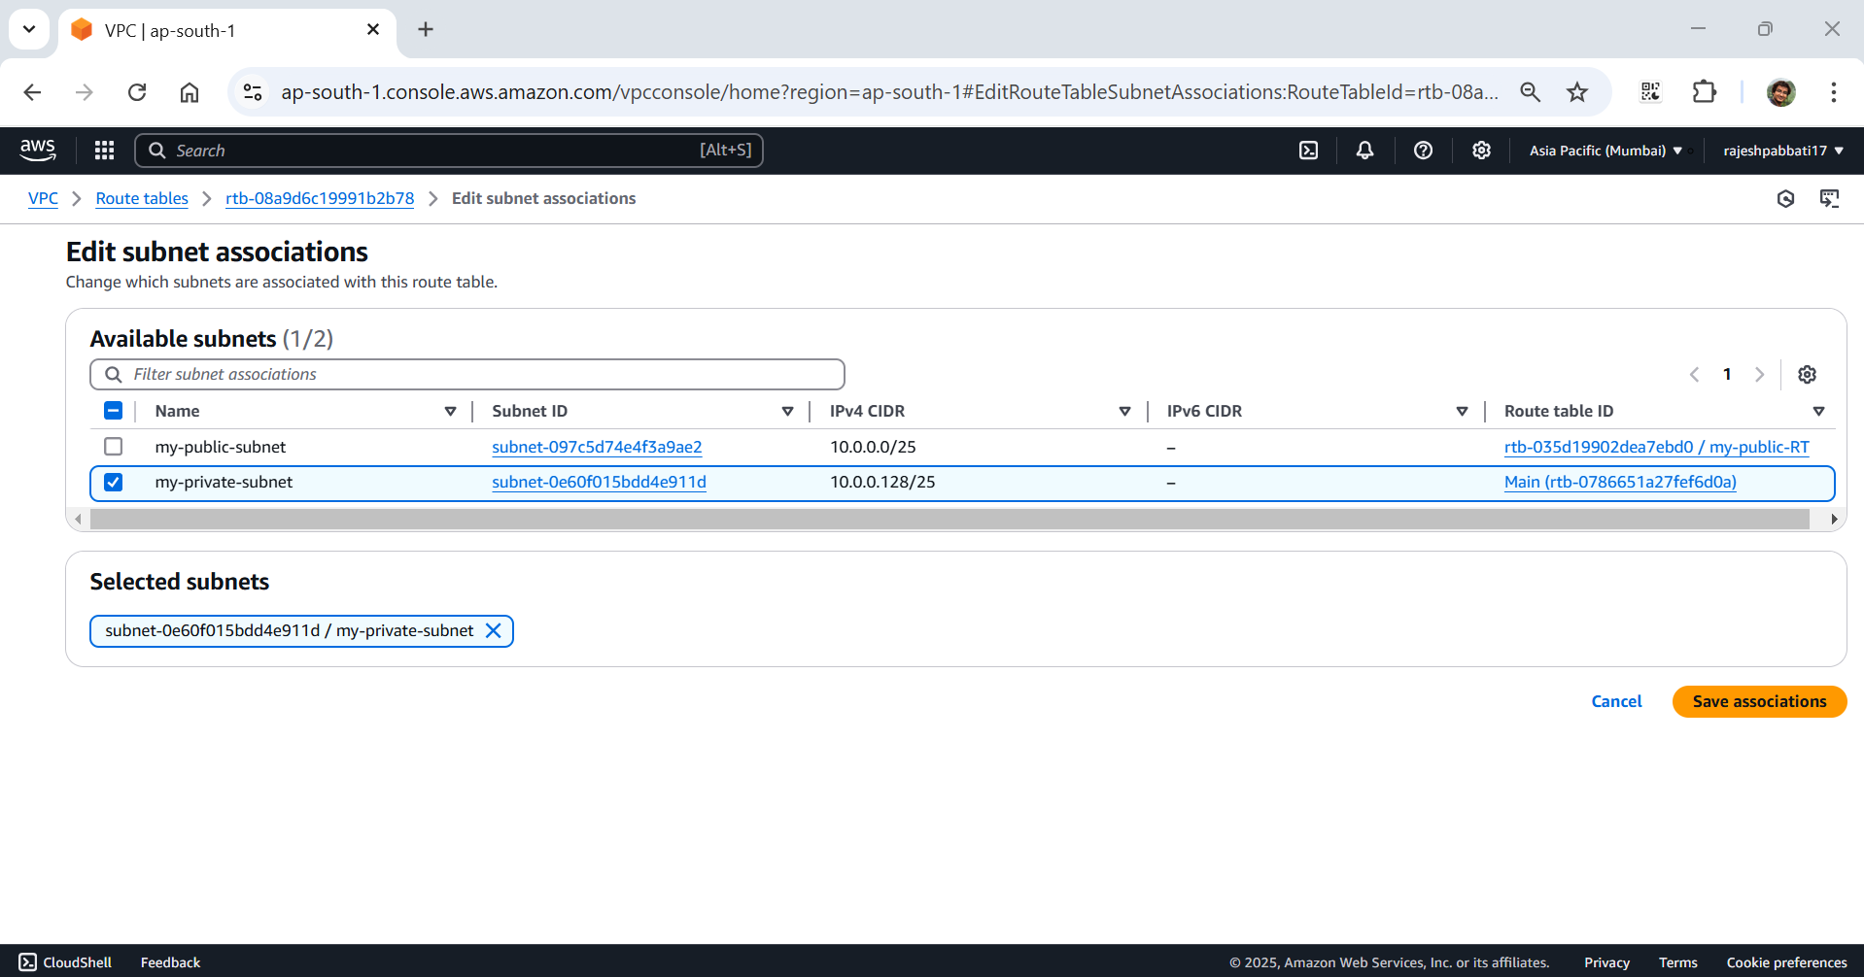

Success message will be display

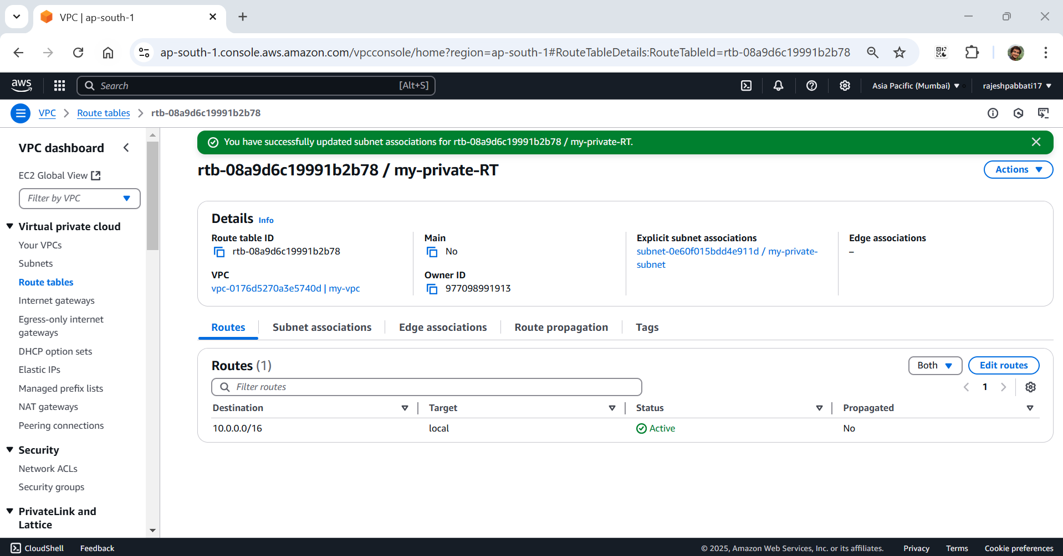

Select Compute service and then click on EC2

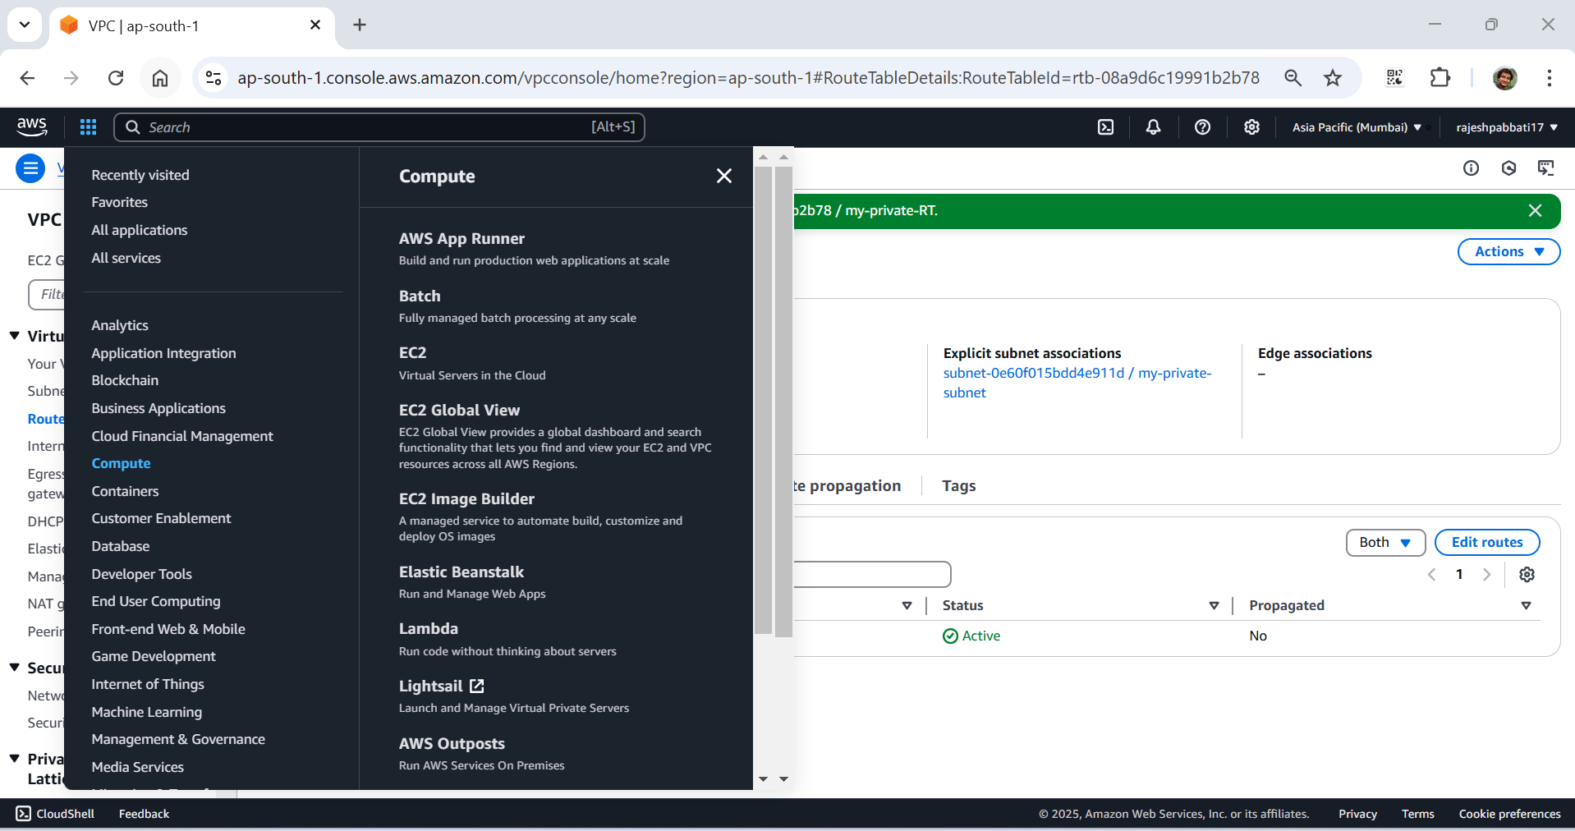

Click on Instances and then click on Launch instances

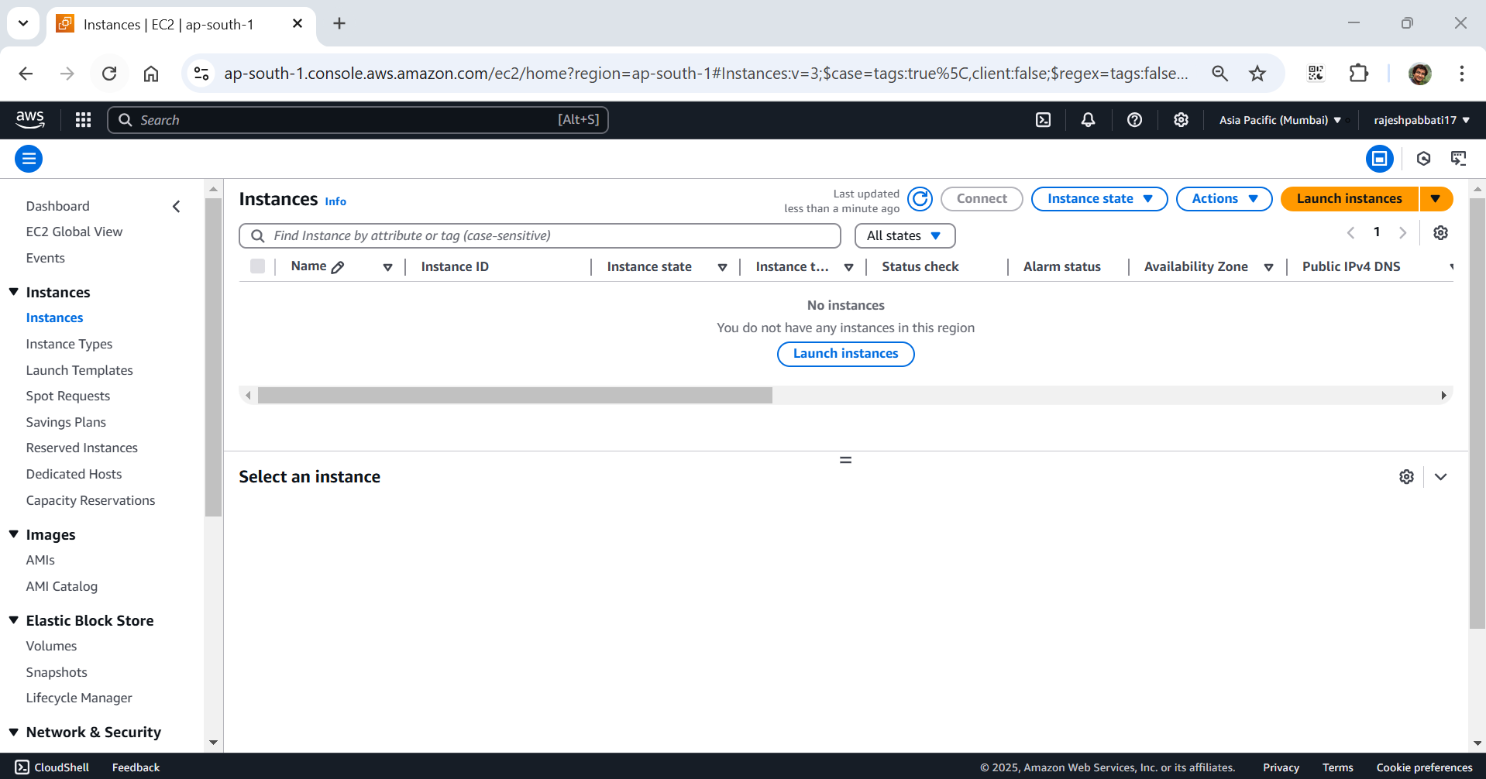

Enter name as my-win-pub-ser and select windows AMI and choose version Microsoft Windows Server 2022 Base Free tire eligible

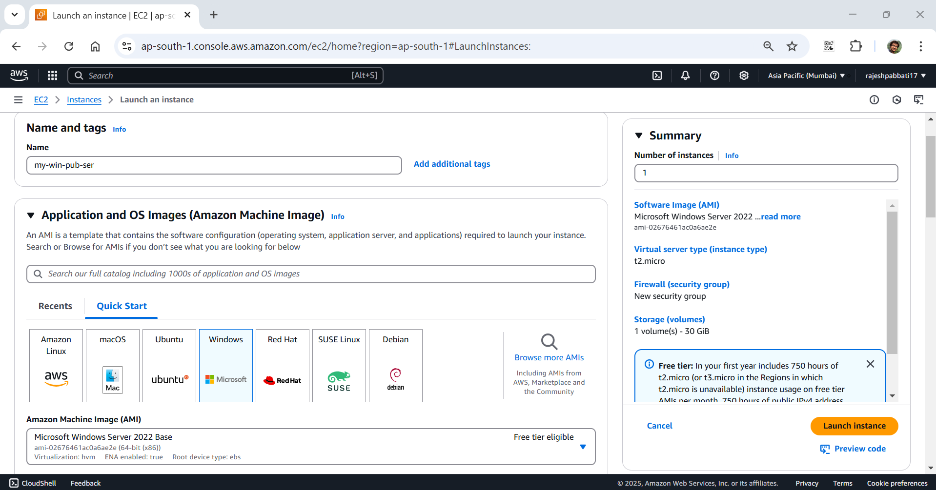

Choose default Instance type and key pair and then click on Edit under Network settings

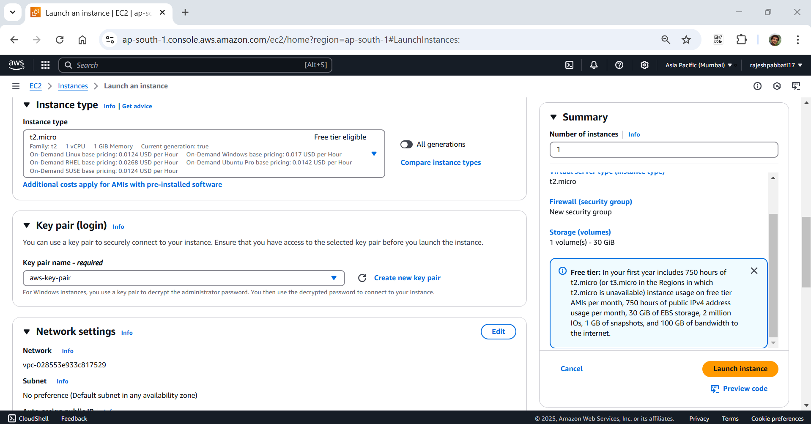

Select my-vpc, my-public-subnet, select existing security group choose default. Then click on Launch Instance

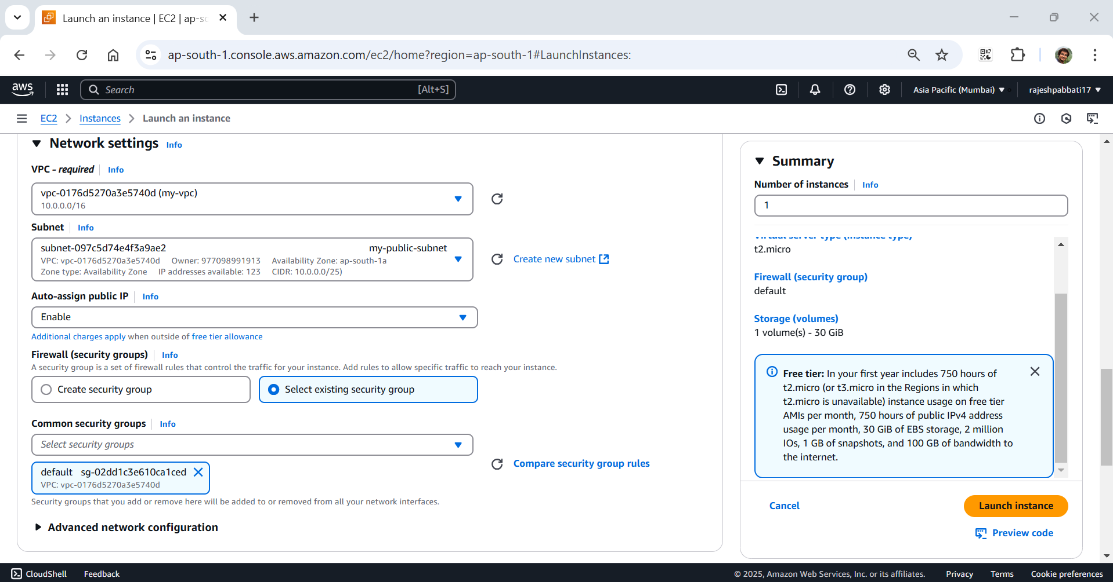

Click on Launch Instance

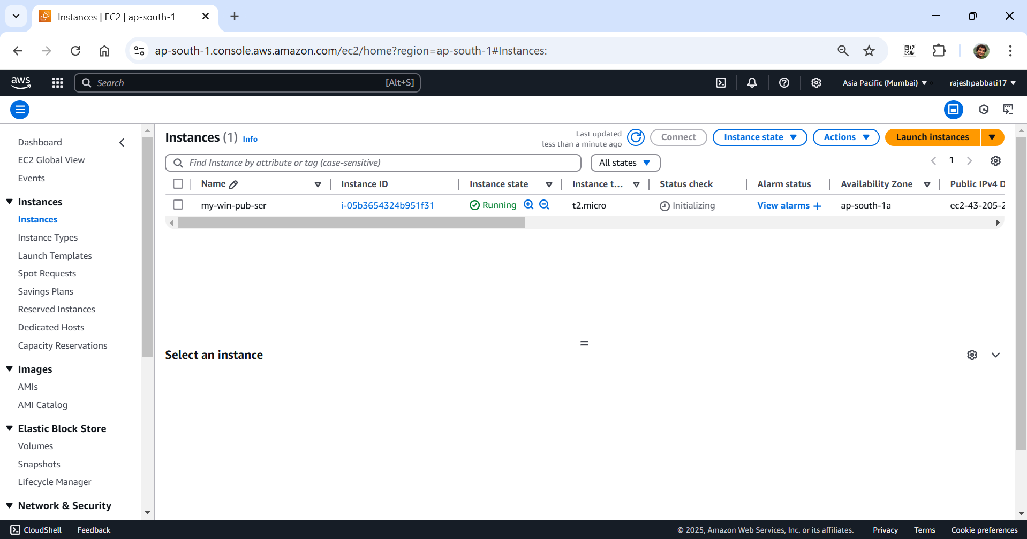

Enter name as my-win-pri-ser select windows AMI Microsoft Windows Server 2022 Base

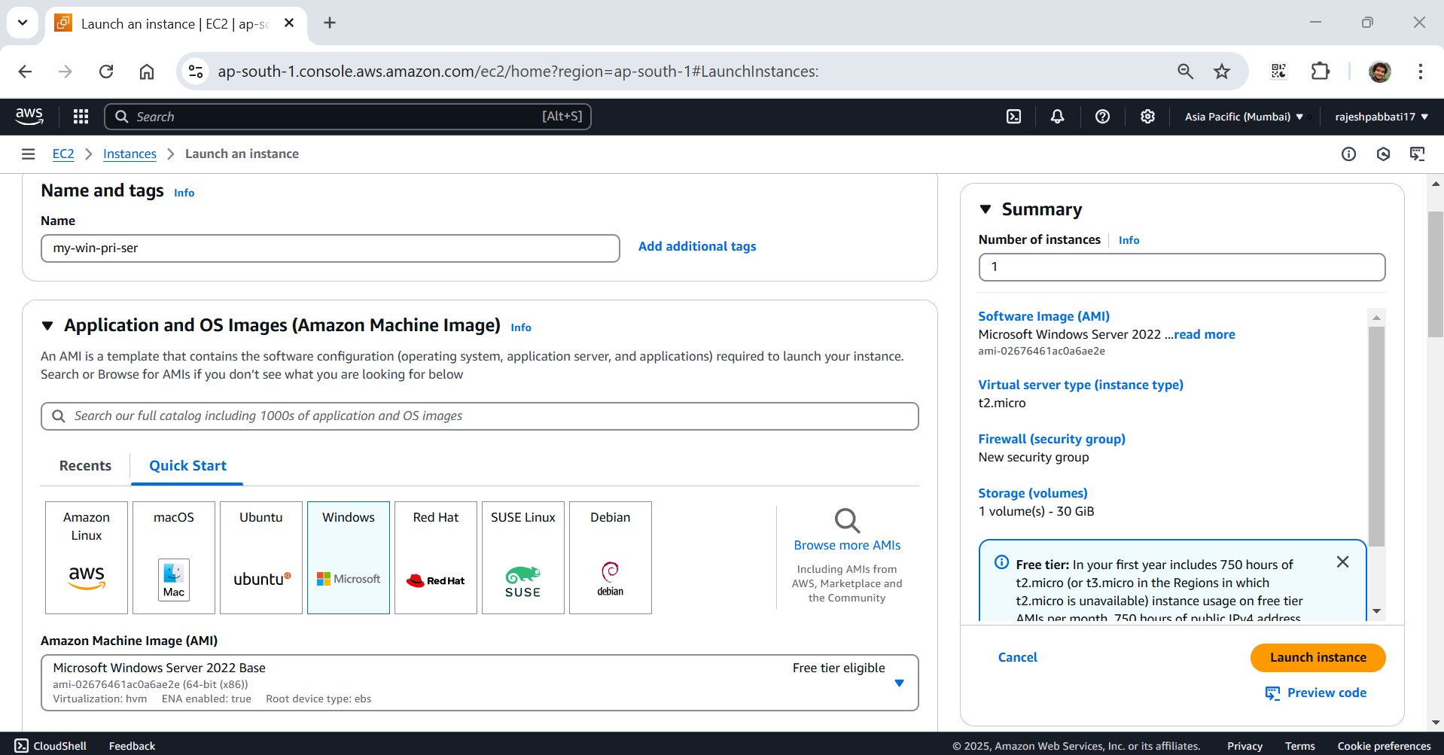

Default instance type, key pair, and then click on Edit under Network settings

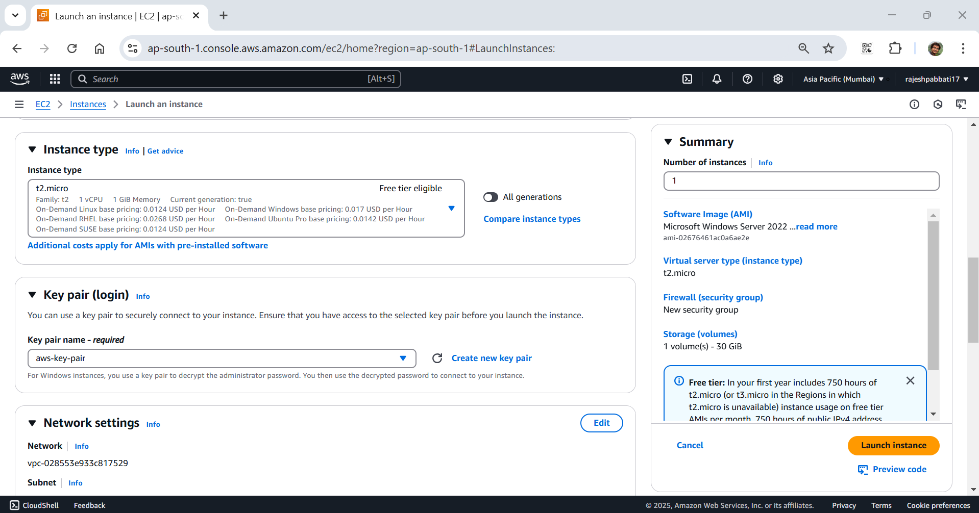

Select my-vpc, my-private-subnet and select existing security group default then click on Launch Instance

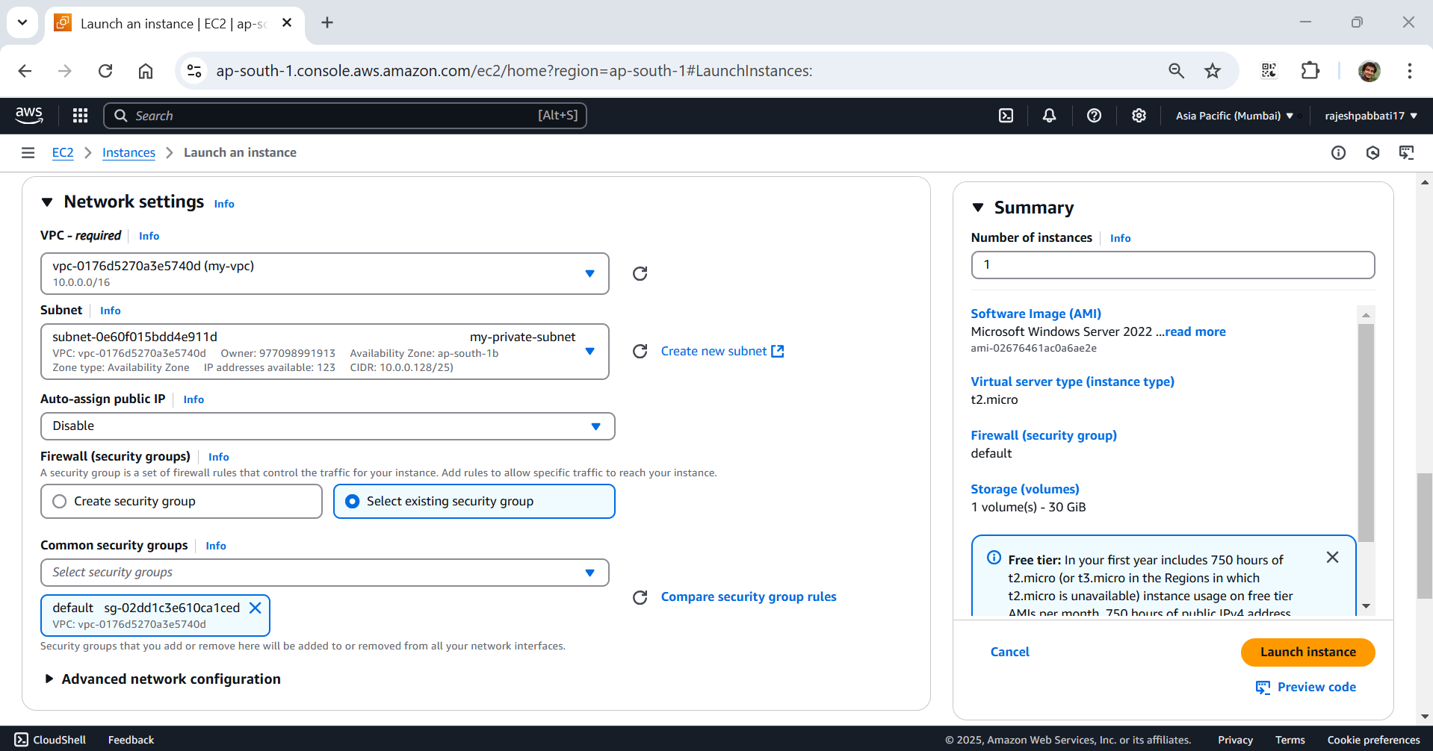

Instance are running select my-win-pub-ser and click on security

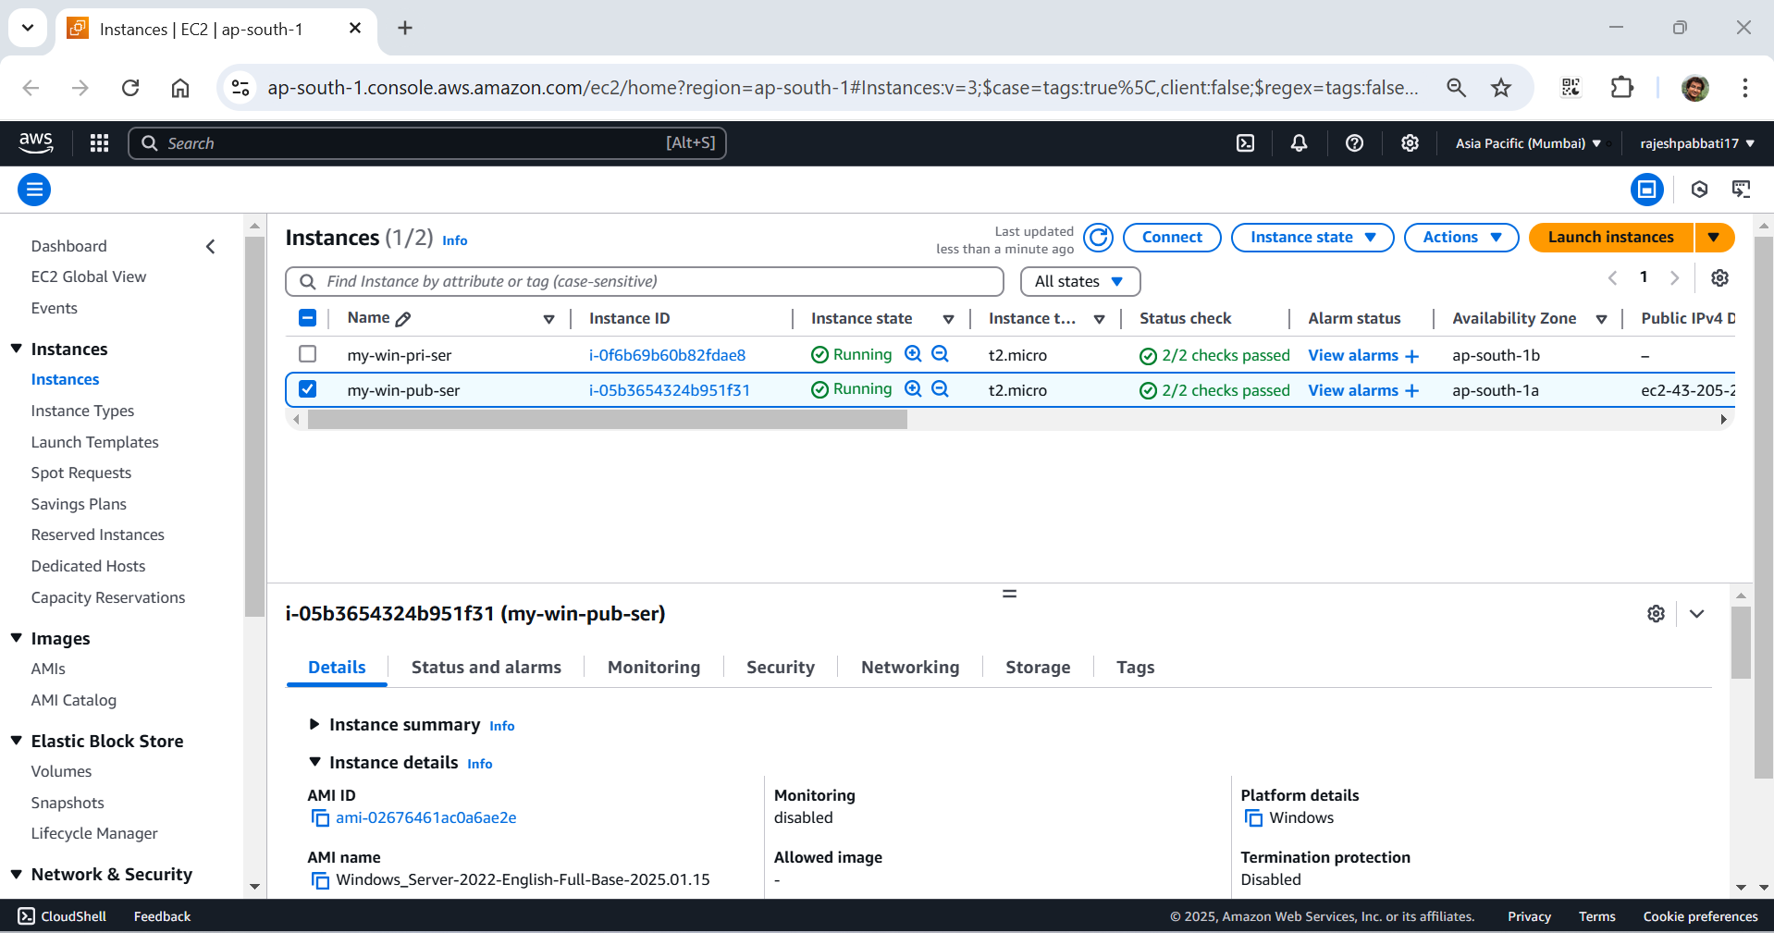

Click on security groups

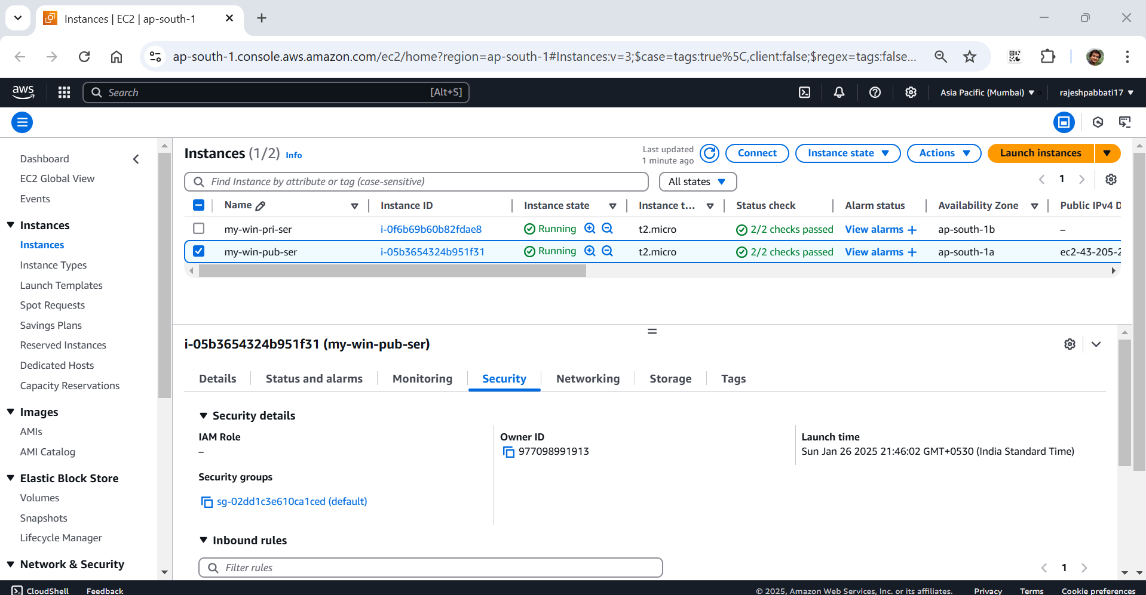

Under inbound rules click on Edit inbound rules

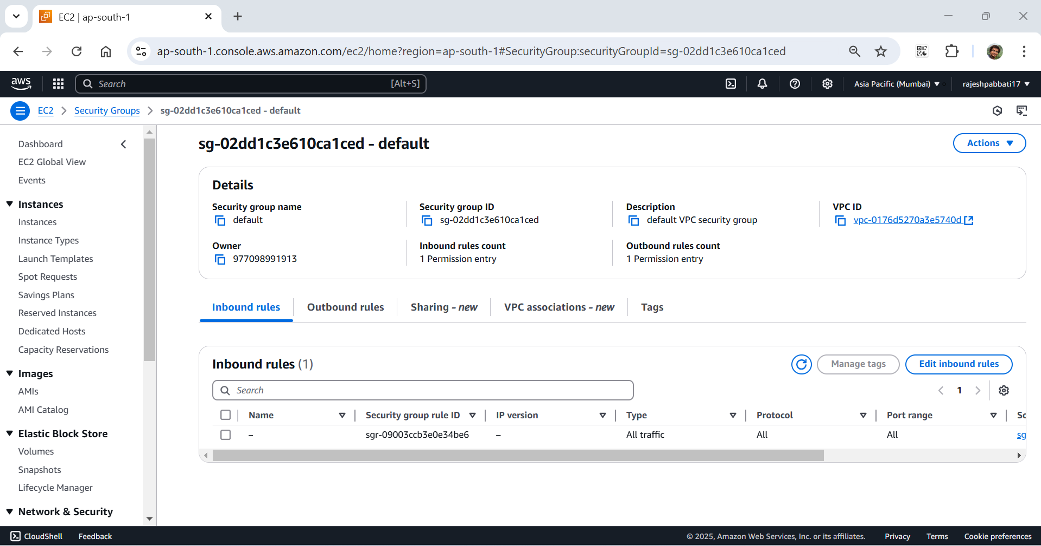

Click on Add rule

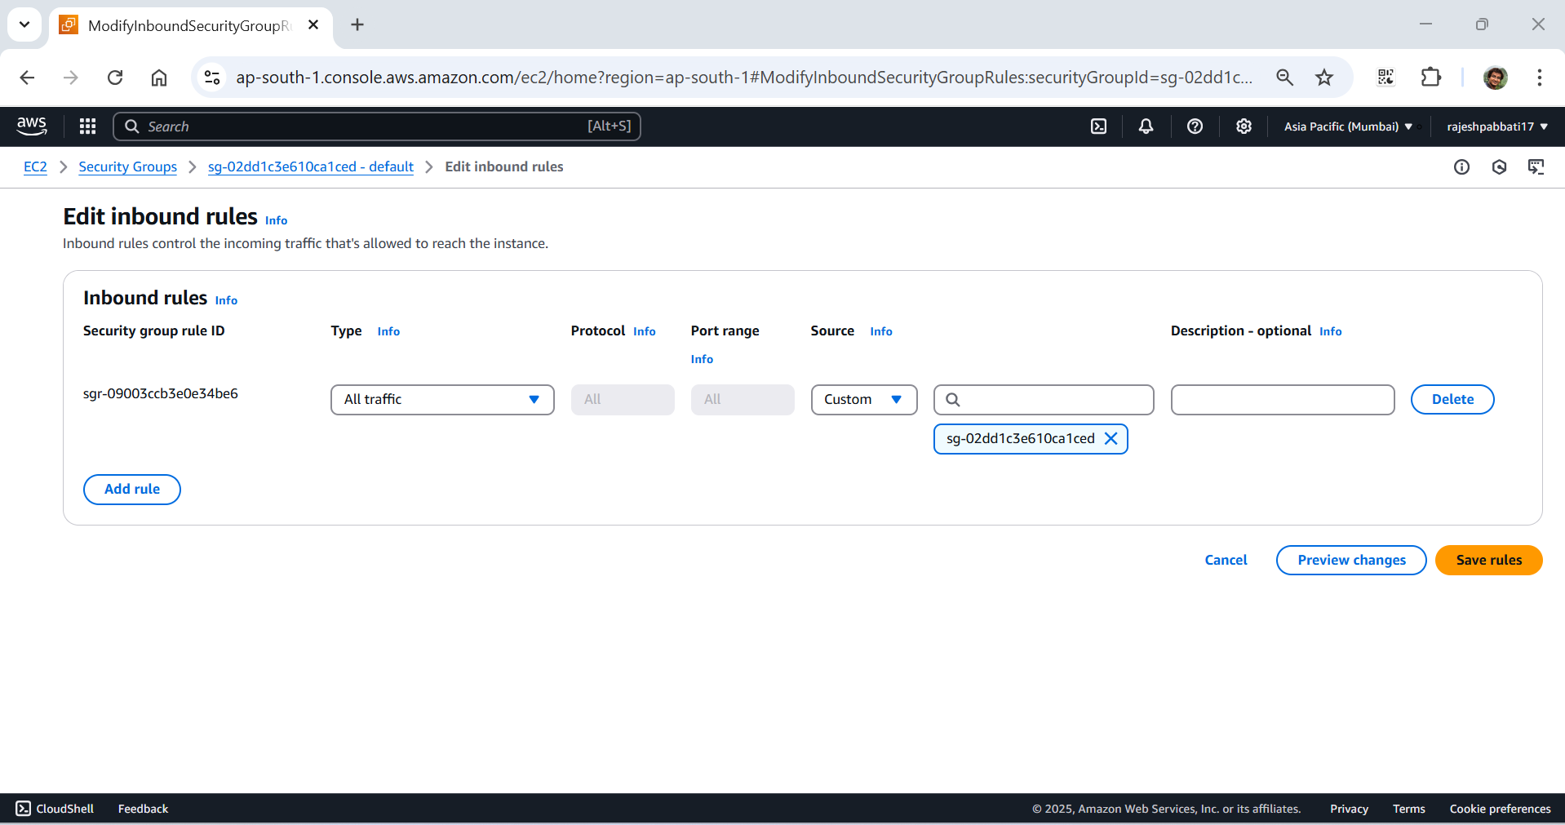

Under Type select RDP under source select Anywhere IPV4 and click on Save rules

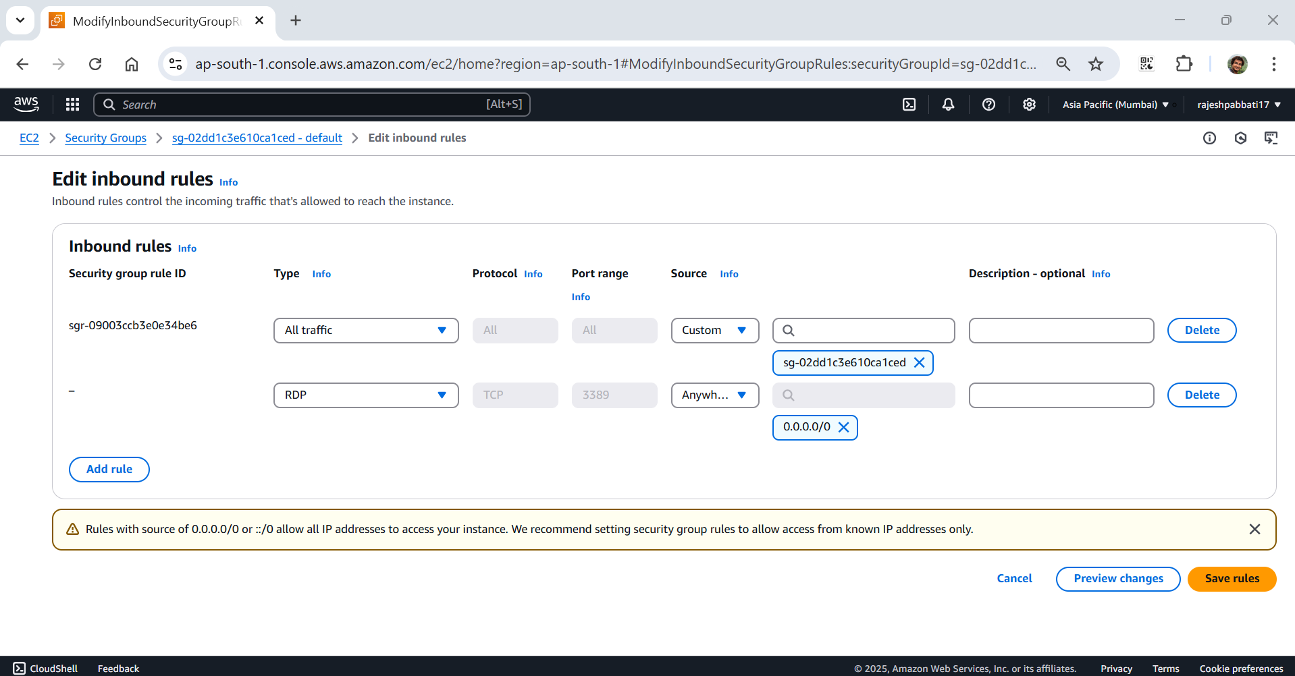

Select my-win-pub-ser, copy Public IPv4 address and click on Connect

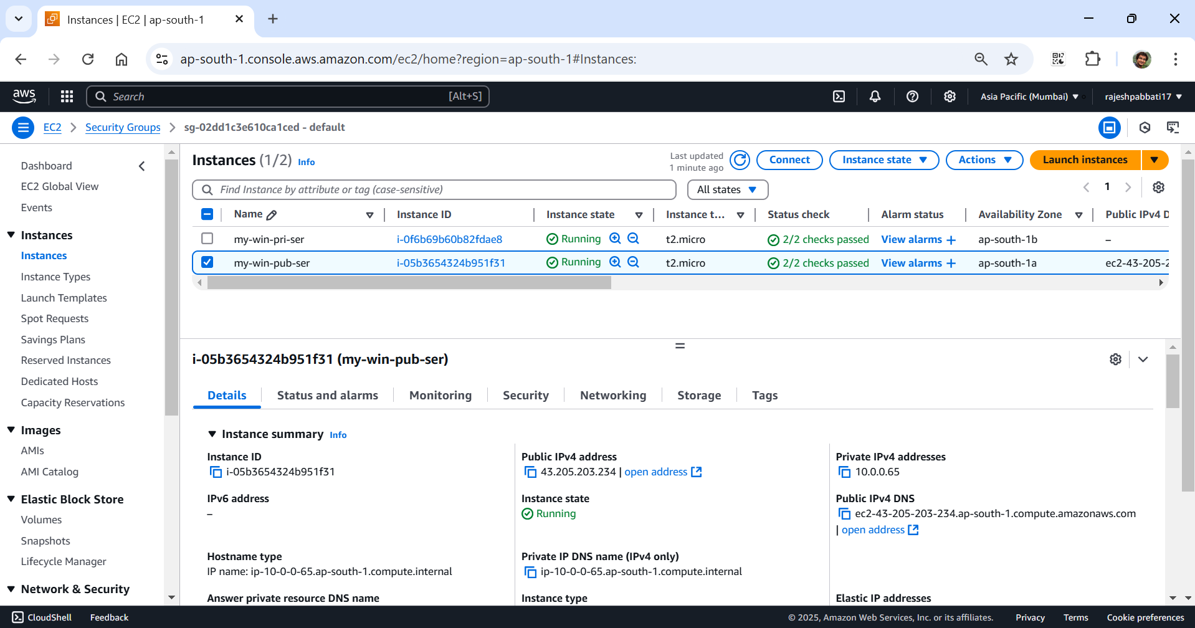

Click on RDP client

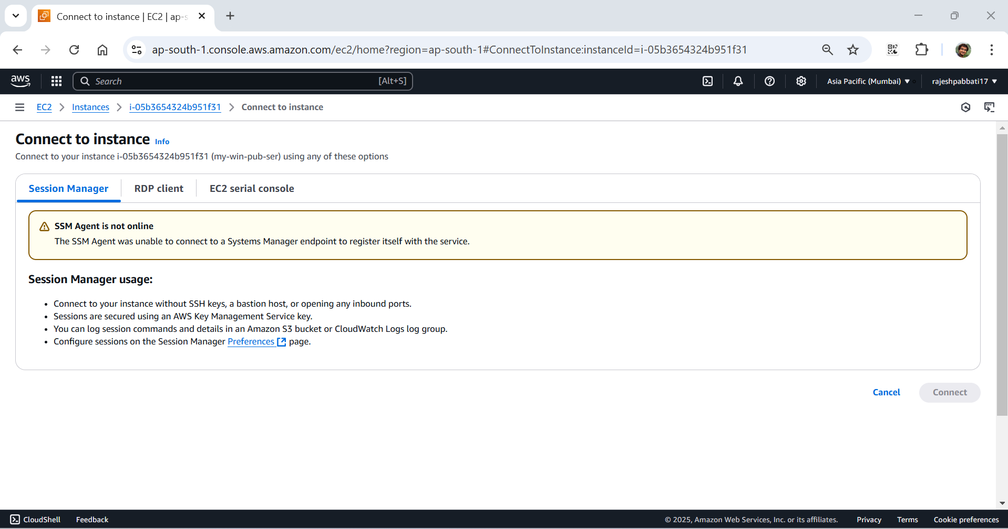

Open RDP from local system

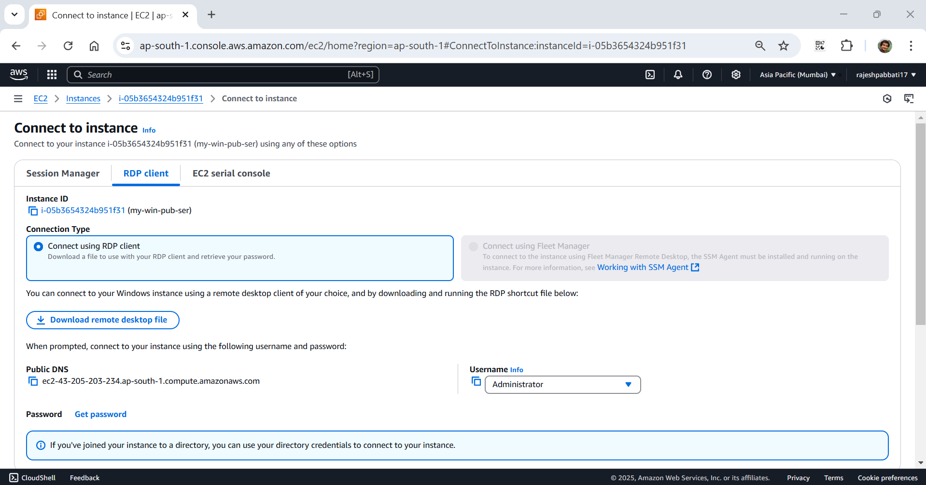

Enter public ip and click on connect

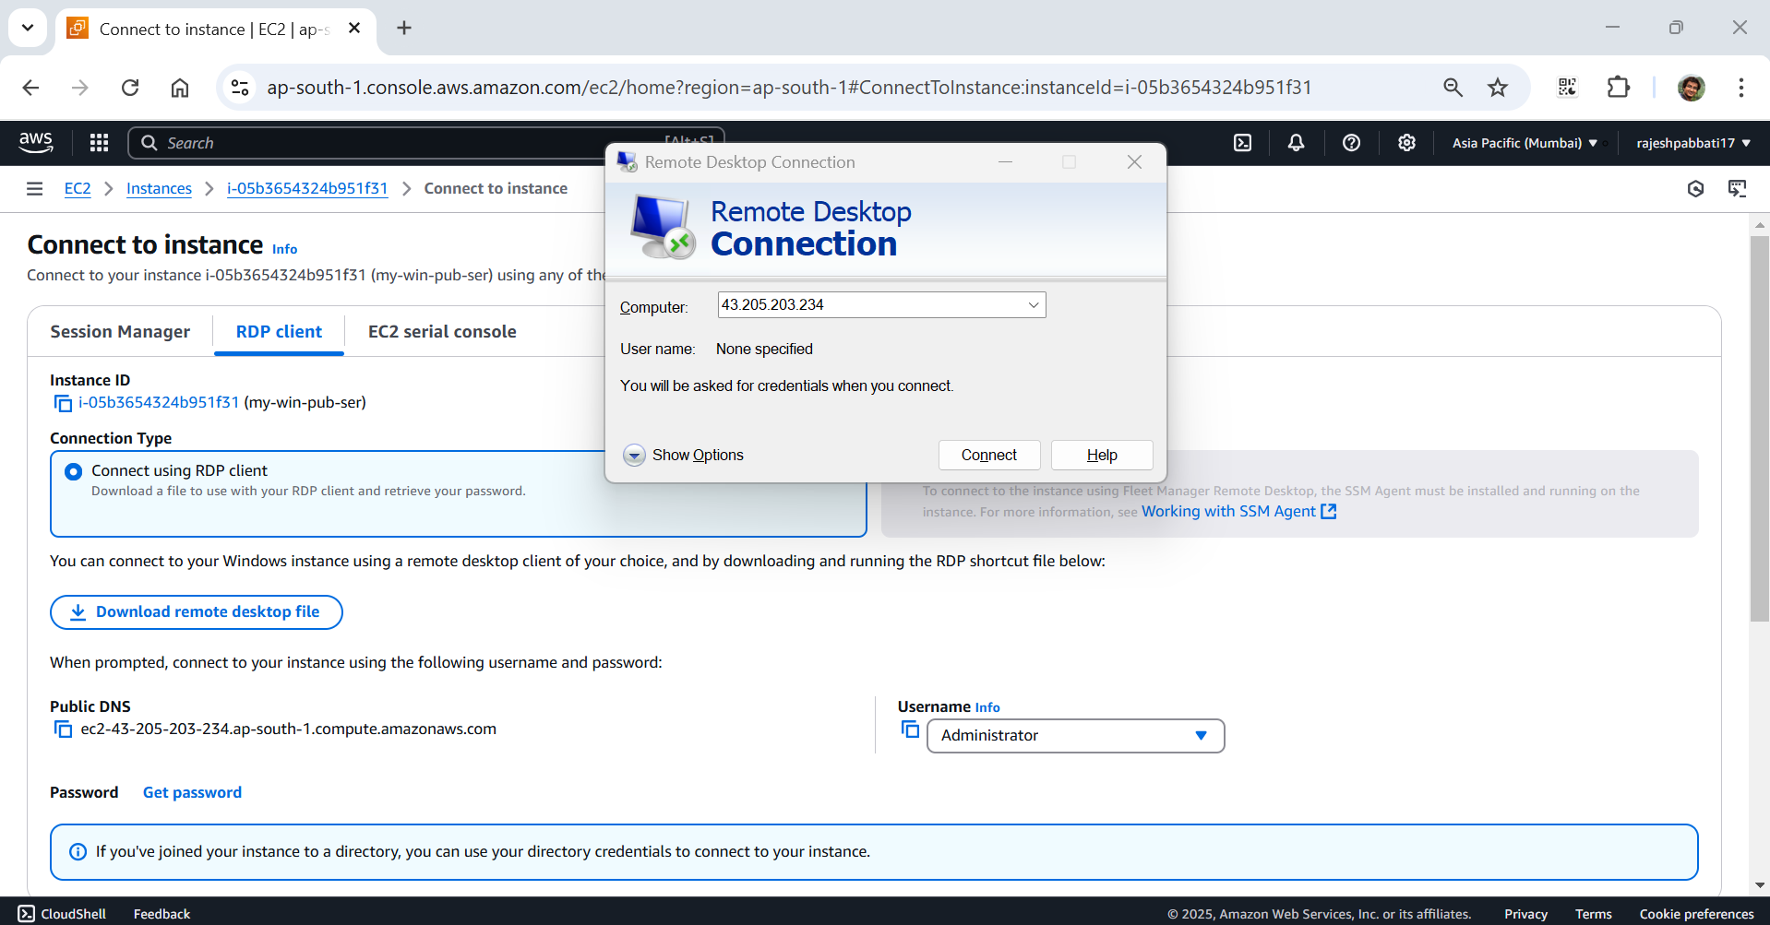

Enter user name Administrator

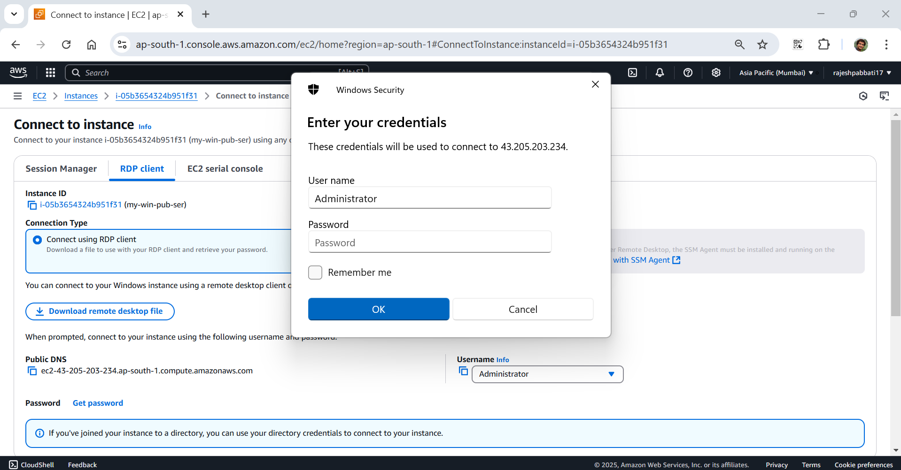

Click on Get password

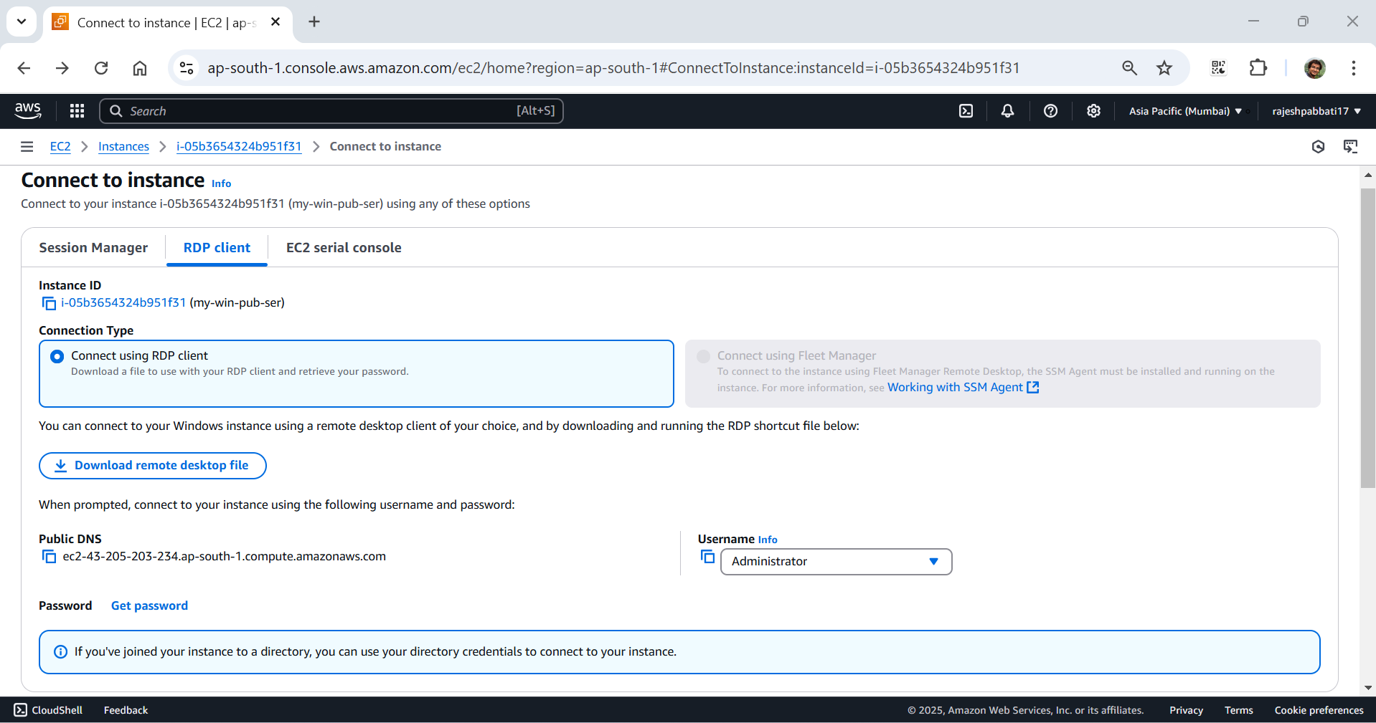

Upload private key file and click on Decrypt password

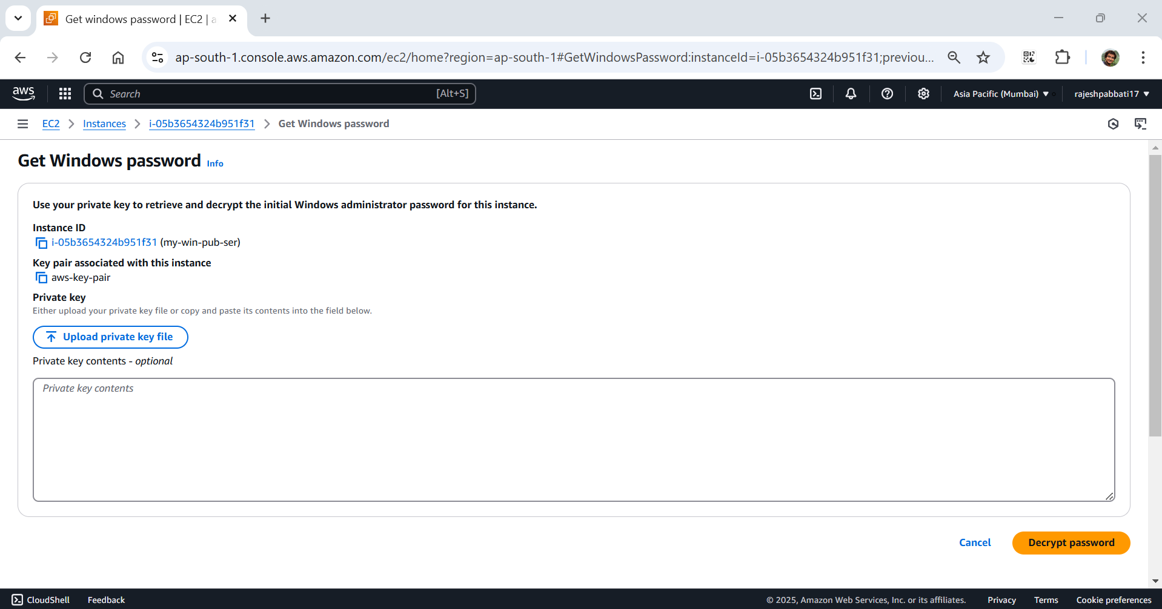

Copy password

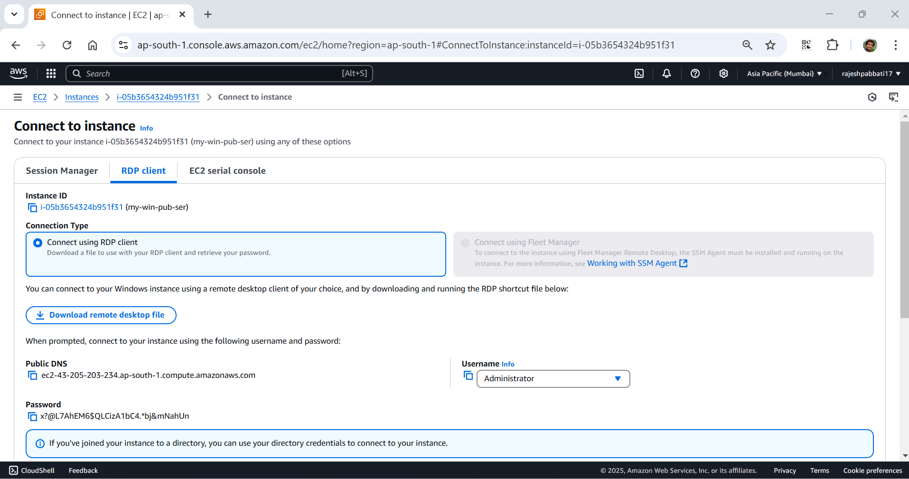

Paste the password and click on ok

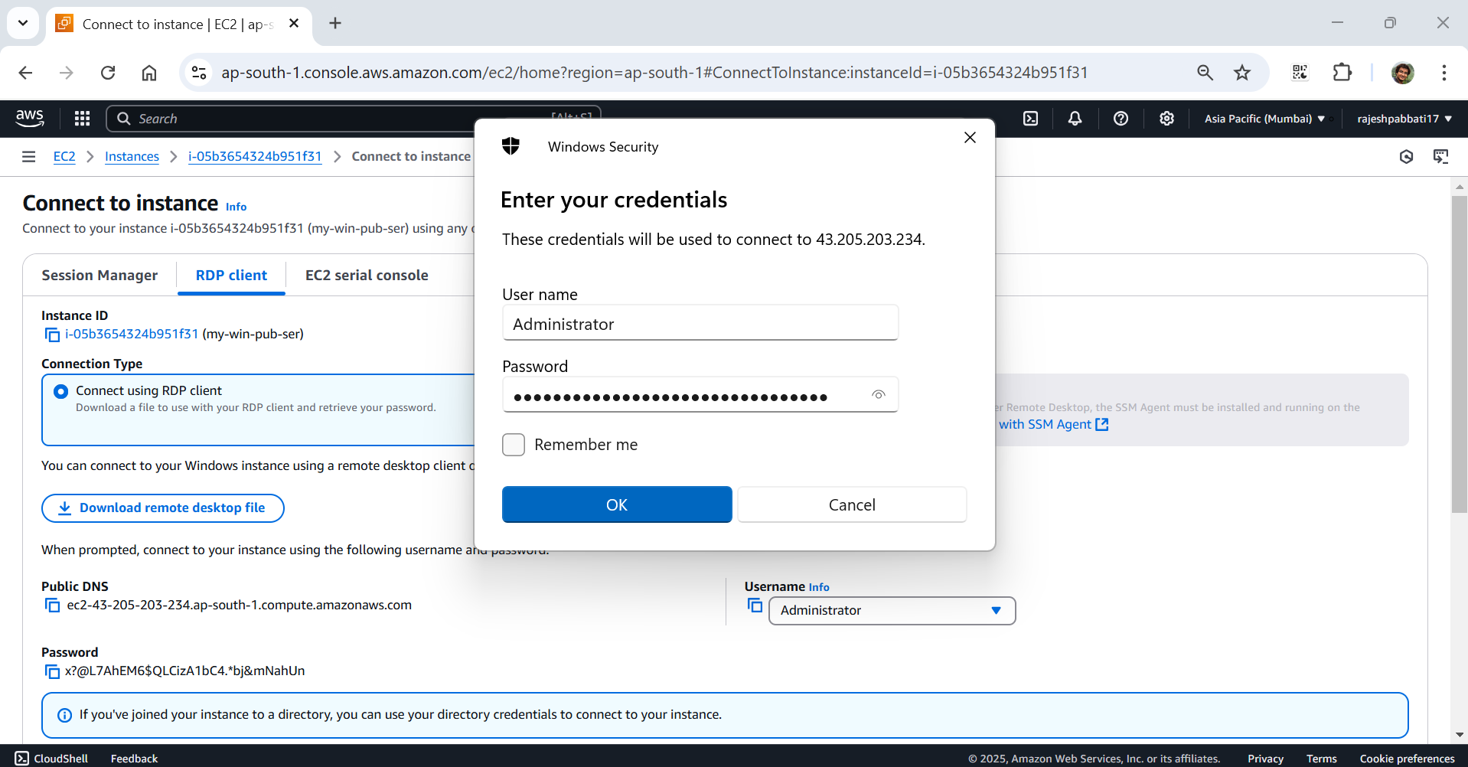

Server connected and opened

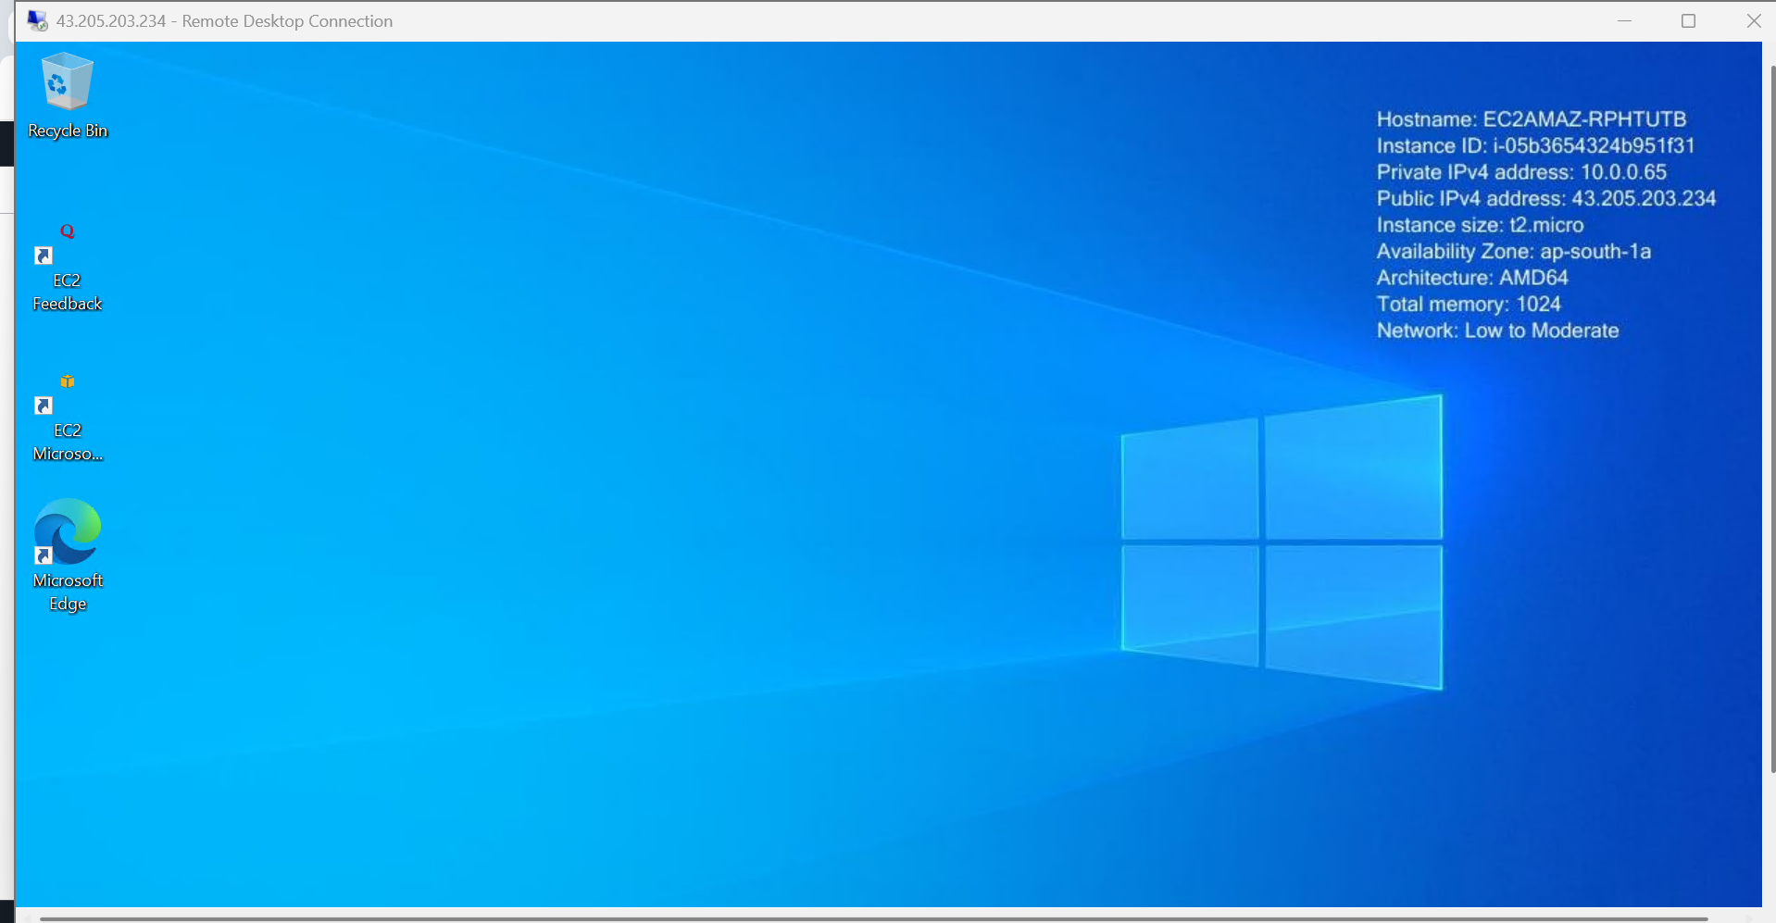

Select my-win-pri-ser, copy the Private IPv4 address and click on connect

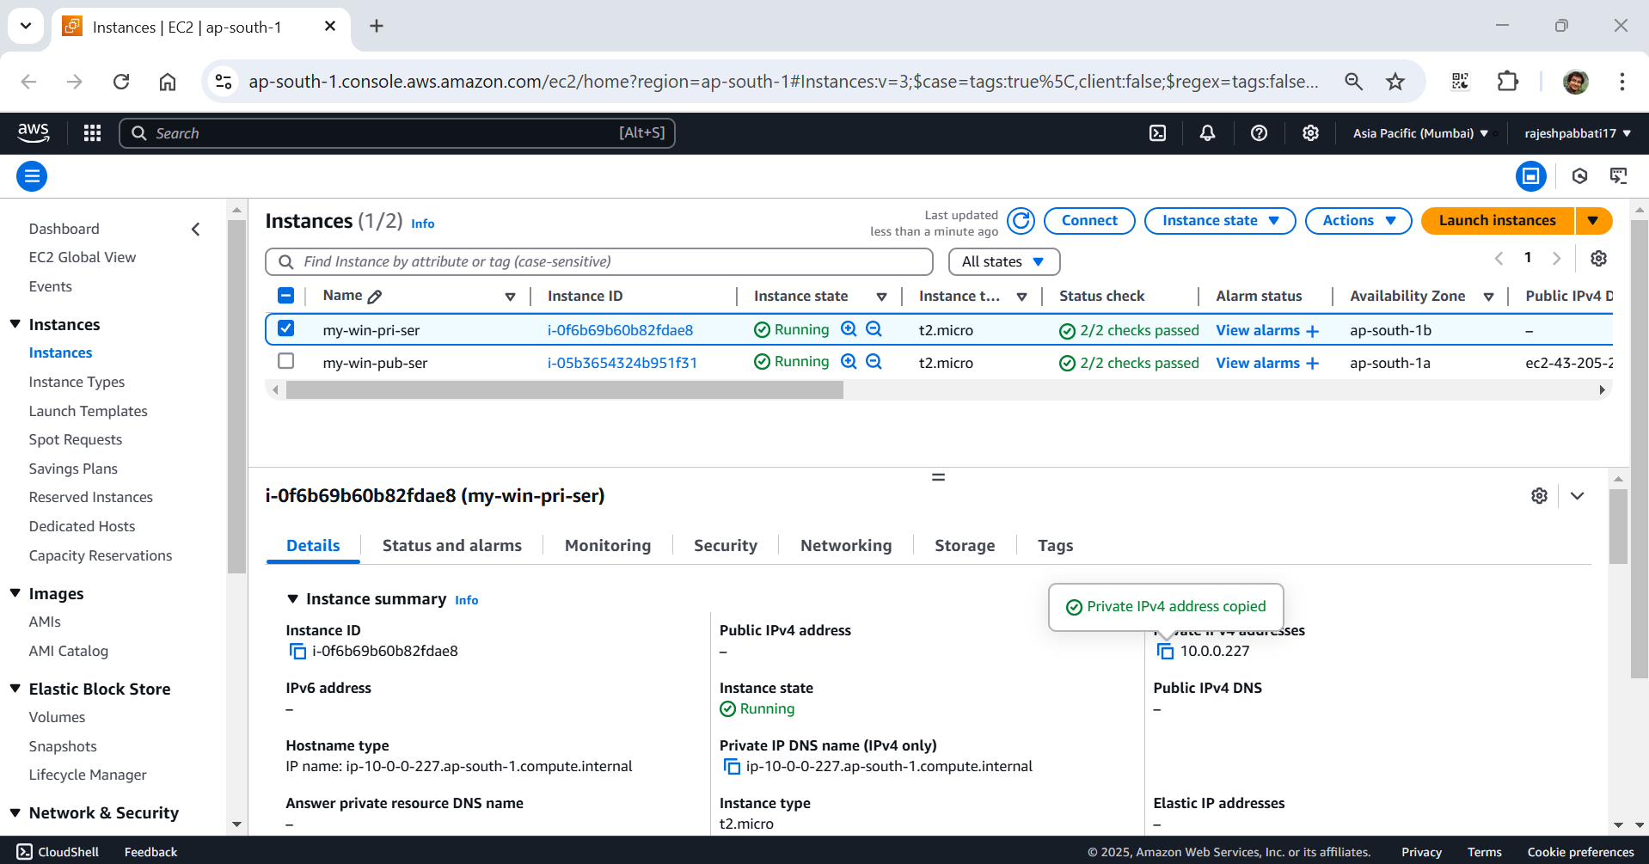

Open RDP from my-win-pub-ser and enter the private ip and click on connect

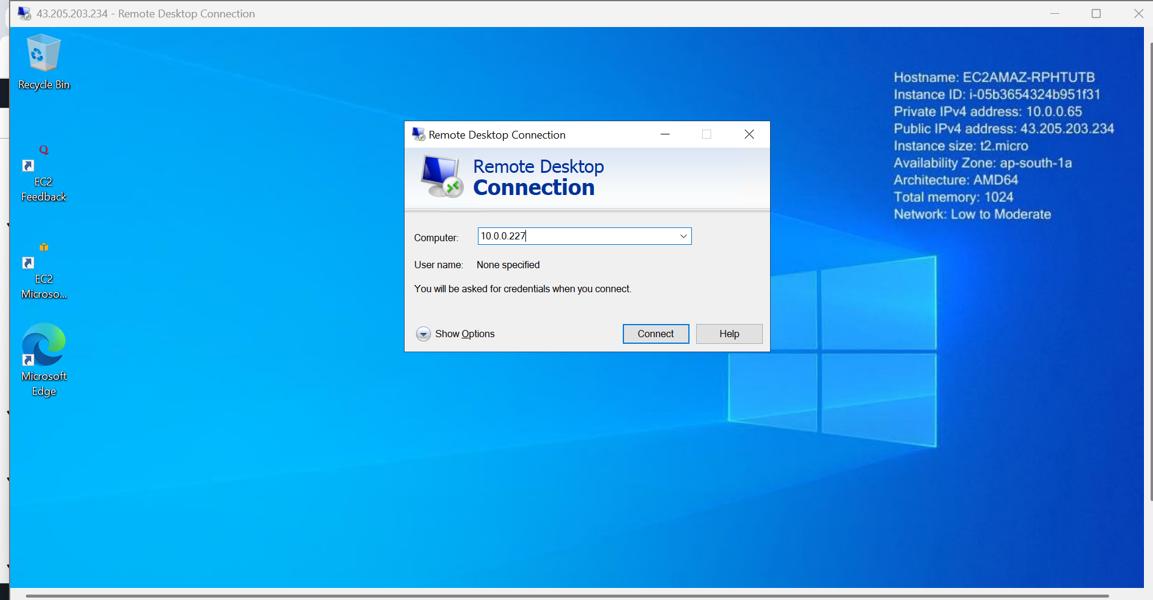

Enter username and password and click on ok

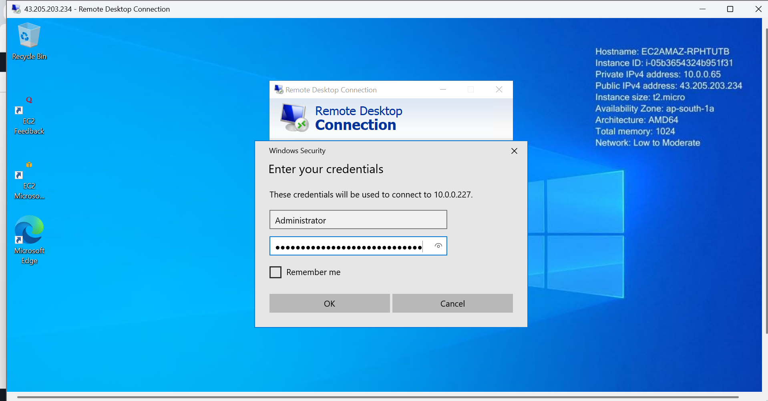

Private connected from public server.

